**Project Report**

For

**Arham Institute Management System**

**(Team-4)**

**Acknowledgement**

We take this opportunity to express our gratitude and deep regards to our course instructor Prof. Asim Banerjee and Teaching Assistant Bhautik Gosai for their exemplary guidance, monitoring and constant encouragement throughout the course of this project.

We also take this opportunity to express a deep sense of gratitude to all the Teaching Assistance for their cordial support, valuable information and guidance which helped us in completing this project through various stages.

Table of Contents

**1) Introduction4**

1.1) System Introduction4

1.2) System Scope4

1.3) Motivation4

1.4) Technology Overview4

**2) System Requirement Study5**

2.1) Functional Requirements5

2.2) Non-Functional Requirements6

**3) System Analysis7**

3.1) Study of System7

3.2) System Modules and Description7

3.3) Feasibility Study8

**4) Project Management.10**

4.1) SDLC Model used : Iterative Waterfall Model10

4.2) Project Estimation and Gantt Chart10

**5) System Diagrams12**

5.1) Use Case Diagram12

5.2) Data flow Diagram14

5.3) Activity Diagram15

5.4) Sequence Diagram19

**6) Data Dictionary25**

**7) Snapshots of Admin Side31**

**8) Snapshots of Student Side.55**

**9) Testing.65**

9.1) Test Plan65

9.2) Test Strategy65

9.3) Test Case62

9.4) Test Report70

**10) Conclusion.74**

10.1) Assumptions and Dependencies74

10.2) Limitations74

10.3) Future Scope74

## 1. Introduction

## 1.1 System Introduction

Arham Institute Management System is an online management system by using it the owner of the institute can manage daily activities like attendance of students, fee payment details, salary payment details and can also generate question paper and conduct online exam.

**1.2 System Scope**

The institution will be provided with major facilities like question paper generation, managing student’s attendance, keeping track of various entities which interacts with institution on daily bases like students, faculties, TA/tutors. The system will also keep track of fees payment details of every student and salary management of faculties and TA/tutors. On the other hand, the student can view various details like their result, fee payment status and various message conveyed to them by institution via announcement facility of the system. The faculties will be provided with to-do list functionality. The students will be able to give online exam using this system which will be evaluated by the system itself immediately after their submission.

**1.3 Motivation**

Arham Education is the institute which gives coaching of entrance exam preparation. The institution manages its daily activities manually. The purpose of building the system is to help the institution to keep track of its various data digitally, manage its daily activities efficiently, help faculties to generate question papers automatically and to conduct online exams of generated question papers.

**1.4 Technology overview**

**1.4.1 To develop Arham Institute Management System we have used following technologies**

**1.4.1.1 Front end:** AngularJS 9

**1.4.1.2 Database:** MySQL

**1.4.1.3 Backend:** Node.js (Express Framework)

**2. System Requirement Study**

**2.1 Functional Requirements**

**2.1.1 Admin/owner related**

2.1.1.1 Admin can manage (add, update, delete)batch, student

2.1.1.2 Admin can add fee payment details of the student

2.1.1.3 Admin can manage(add, update, delete) faculty and tutors (TAs)

2.1.1.4 Admin can make announcements

2.1.1.5 Admin can mark attendance

2.1.1.6 Admin can manage questions

2.1.1.7 Admin can manage subjects and topics

2.1.1.8 Admin can add salary payment details of faculties and TA/Tutors

2.1.1.9 Admin can conduct exam

2.1.1.10 Admin can access to-do list

**2.1.2 Faculty related**

2.1.2.1 Faculties can manage questions

2.1.2.2 Faculties can conduct online exams

2.1.2.3 Faculties can make announcements

2.1.2.4 Faculties can access to-do list

2.1.2.5 Faculties can mark attendance

**2.1.3 Tutors/TAs related**

2.1.3.1 Tutors can take attendance of the student

2.1.3.2 Tutor can manage fee payment details of students

2.1.3.3 Tutors can make announcements

2.1.3.4 Tutors can manage question

2.1.3.5 Tutors can conduct online exams

2.1.3.6 Tutors can access to-do list

**2.1.4 Students related**

2.1.4.1 Students can give online exams

2.1.4.2 Students can see their respective results of the exams given

2.1.4.3 Students can see the announcement made for their respective batch

2.1.4.4 Students can see their respective fee payment status

**2.2 Non-functional requirements**

**2.2.1 Performance requirements**

2.2.1.1 The system should be able to operate on all major web browsers with all its functions

2.2.1.2 The application should be responsive i.e. the user must be able to use it on computers, phone, tablets.

**2.2.2Security requirements**

2.2.2.1 The system should provide a secure login to the user and provide access to only authorized users

**3. System analysis**

**3.1 Study of the system**

**3.1.1 Study of the current system**

The institution does not have any existing system. They manage their all the activities manually.

**3.1.2 Problems of not having any system**

The institution faces a lot of problems because of not having any digital system to manage their activities. There are treats of data getting misplaced, not getting desired data in time, not having any online medium to inform something urgent to students and not having any facility to give students the demonstration of online exam.

**3.1.3 Proposed new system**

3.1.3.1 Students, faculties and tutors can be managed easily

3.1.3.2 Institution can easily keep track of fees paid by students

3.1.3.3 Institution can easily keep track of salary paid to faculties

3.1.3.4 Faculties can generate digital question paper using this system.

3.1.3.5 Online examination and result generation functionality is introduced

3.1.3.6 Attendance of the students can be recorded using this system.

**3.2 System modules and description**

**3.2.1 Register and Login Capability**

Information of the system must be predefined, so that the system can maintain the integrity, reliability and acceptance of the information. So as to have the privilegeof performing certain activities one must be registered on the system authorized list by contacting the system operator physically. The system shall provide login capability for authorized personnel only.

**3.2.2 Student/Faculty/TA/Subject management**

The student, batch, faculty, TA management functionality will keep track of the person working in the institution and all the students studying in the institution. Subject management will keep track of which faculty teaches which subject and other details related to subjects. The details regarding the same can be stored and fetched efficiently.

**3.2.3 Question paper generation**

The system generates question paper by sorting out questions by complexity/difficulty as per instructions to generate a question paper. The Question paper generator system should be stable and secured and have high performance.

**3.2.4 Attendance**

Student attendance system deal with management of the student’s attendance details. It marks the student’s attendance on the basis of his/her presence in the institution on a particular day and maintains the same which later can be used for analysis purpose.

**3.2.5 Announcement**

Announcement functionality provides facility of notifying students about certain things such as work, holidays, results and other things which institution wants. Admin/Owner, Faculty, Tutor everyone can make announcements.

**3.2.6 To do list**

The functionality of to-do list helps the faculty to keep track of what is done in the academic curriculum and what is to be done. Through this functionality faculty can Manage the academic activities easily.

**3.2.7 Online exam and result generation**

Students can give exams of the question paper generated by the faculty. The result of that exam is evaluated by the system immediately after the student submits his/her attempt.

**3.2.8 Fees and salary management**

Student’s fees detail and faculty’s salary details can be stored in the database so that admin can keep track of how much fees a particular student has paid, how much salary has been paid and how much is yet to be paid.

**3.3Feasibility Study**

**3.3.1 Technical feasibility**

3.3.1.1 The system is capable of running on all major web browsers.

3.3.1.2 The system is responsive which means users can use it on any device like computers, phones and tablets.

3.3.1.3 The system works well on the web and gives all the functionalities that client asked

3.3.1.4 The system is technically feasible in the sense that all the resources that are used are extensive.

**3.3.2 Economical feasibility**

3.3.2.1 The system is economically feasible as the institution doesn’t need to buy any extra devices or purchase anything (as they already have a computer and good internet facility)

3.3.2.2 The institution does not need to train people for using the system

3.3.2.3 The system development costs are one-time costs which will not occur after the project has been completed

3.3.2.4 The cost of the system is only of hosting the system which is hosted by using one of the member’s existing plan for a month after that the owner will host it on their domain. So, it is cost friendly.

**3.3.3 Operational feasibility**

3.3.3.1 The system interface is standard, user-friendly and provides extensive help. Hence no training required.

3.3.3.2 All the operations are extensive and work deeply with the databases.

**4. Project Management**

**4.1 SDLC Model Used: Iterative Waterfall Model**

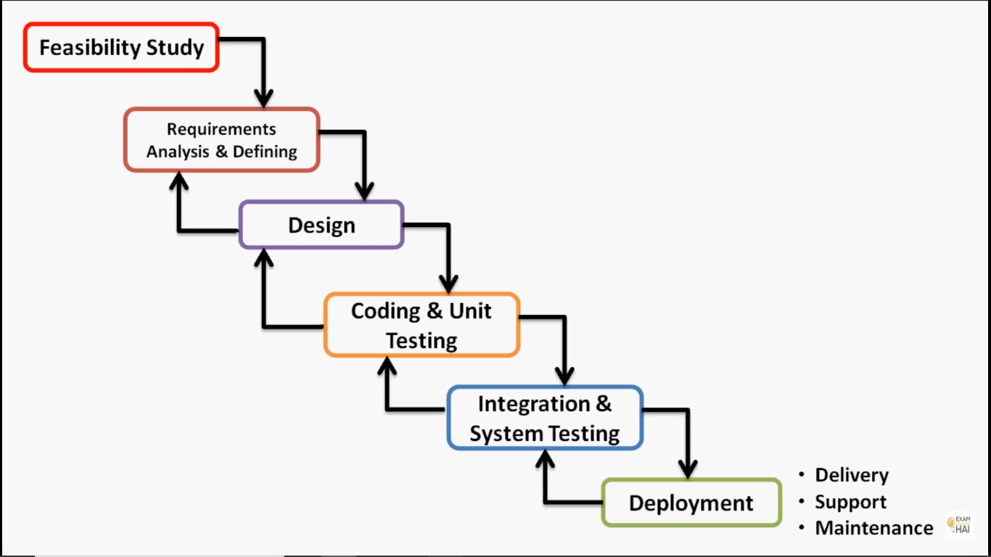

Iterative waterfall model is almost same as the Classic Waterfall Model except the developers are free to go into the previous phases of development to make any sort of modification or changes.

**4.2 Project Estimation and Gantt chart**

**4.2.1 Estimation:-**

|  |  |  |  |
| --- | --- | --- | --- |
| **Task** | **Start Date** | **Duration (in days)** | **End Date** |
| Feasibility Study | 13-01-2020 | 20 | 01-02-2020 |
| Requirement Gathering | 02-02-2020 | 20 | 22-02-2020 |
| Design | 23-02-2020 | 16 | 10-03-2020 |
| Coding and Unit Testing | 11-03-2020 | 30 | 10-04-2020 |
| Integration and System Testing | 11-04-2020 | 42 | 23-05-2020 |
| Deployment | 24-05-2020 | 7 | 31-05-2020 |

**4.2.2 Actual Progress:-**

|  |  |  |  |
| --- | --- | --- | --- |
| **Task** | **Start Date** | **Duration (in days)** | **End Date** |
| Feasibility Study | 13-01-2020 | 22 | 03-02-2020 |
| Requirement Gathering | 04-02-2020,  15-03-2020 | 21,  2 | 24-02-2020,  16-03-2020 |
| Design | 25-02-2020,  17-03-2020 | 19,  2 | 14-03-2020,  18-03-2020 |
| Coding and Unit Testing | 19-03-2020 | 32 | 19-04-2020 |
| Integration and System Testing | 20-04-2020 | 38 | 27-05-2020 |
| Deployment | 28-05-2020 | 10 | 06-06-2020 |

**5. System Diagrams**

**5.1 Use case Diagram**

**5.1.1 Admin, Faculty and Tutor**

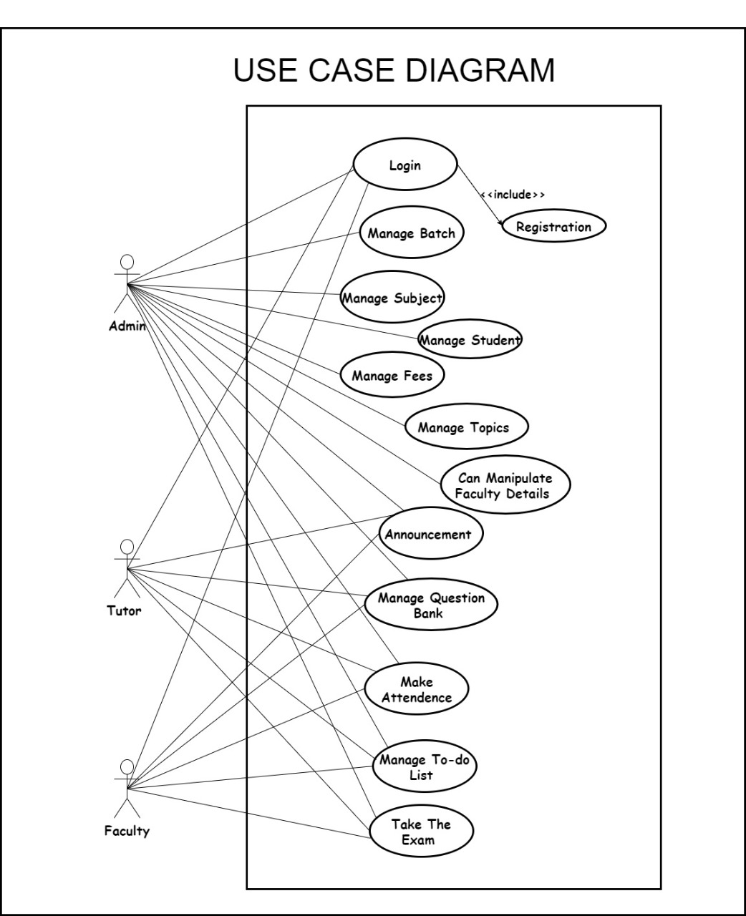

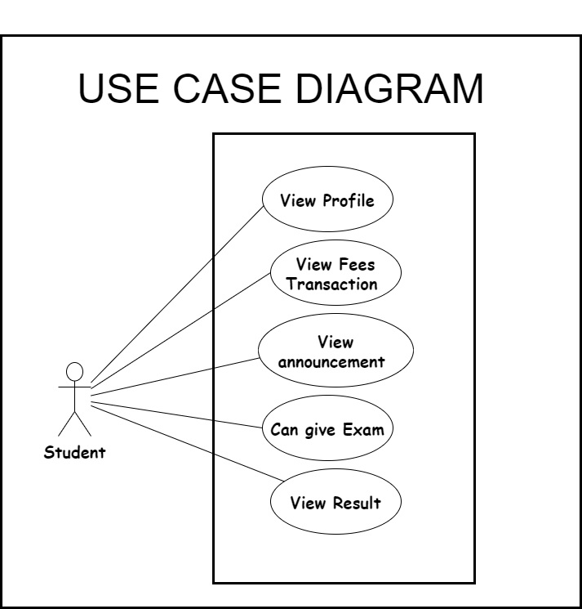**5.1.2 Student**

**5.2 Data flow Diagram: Level 0**

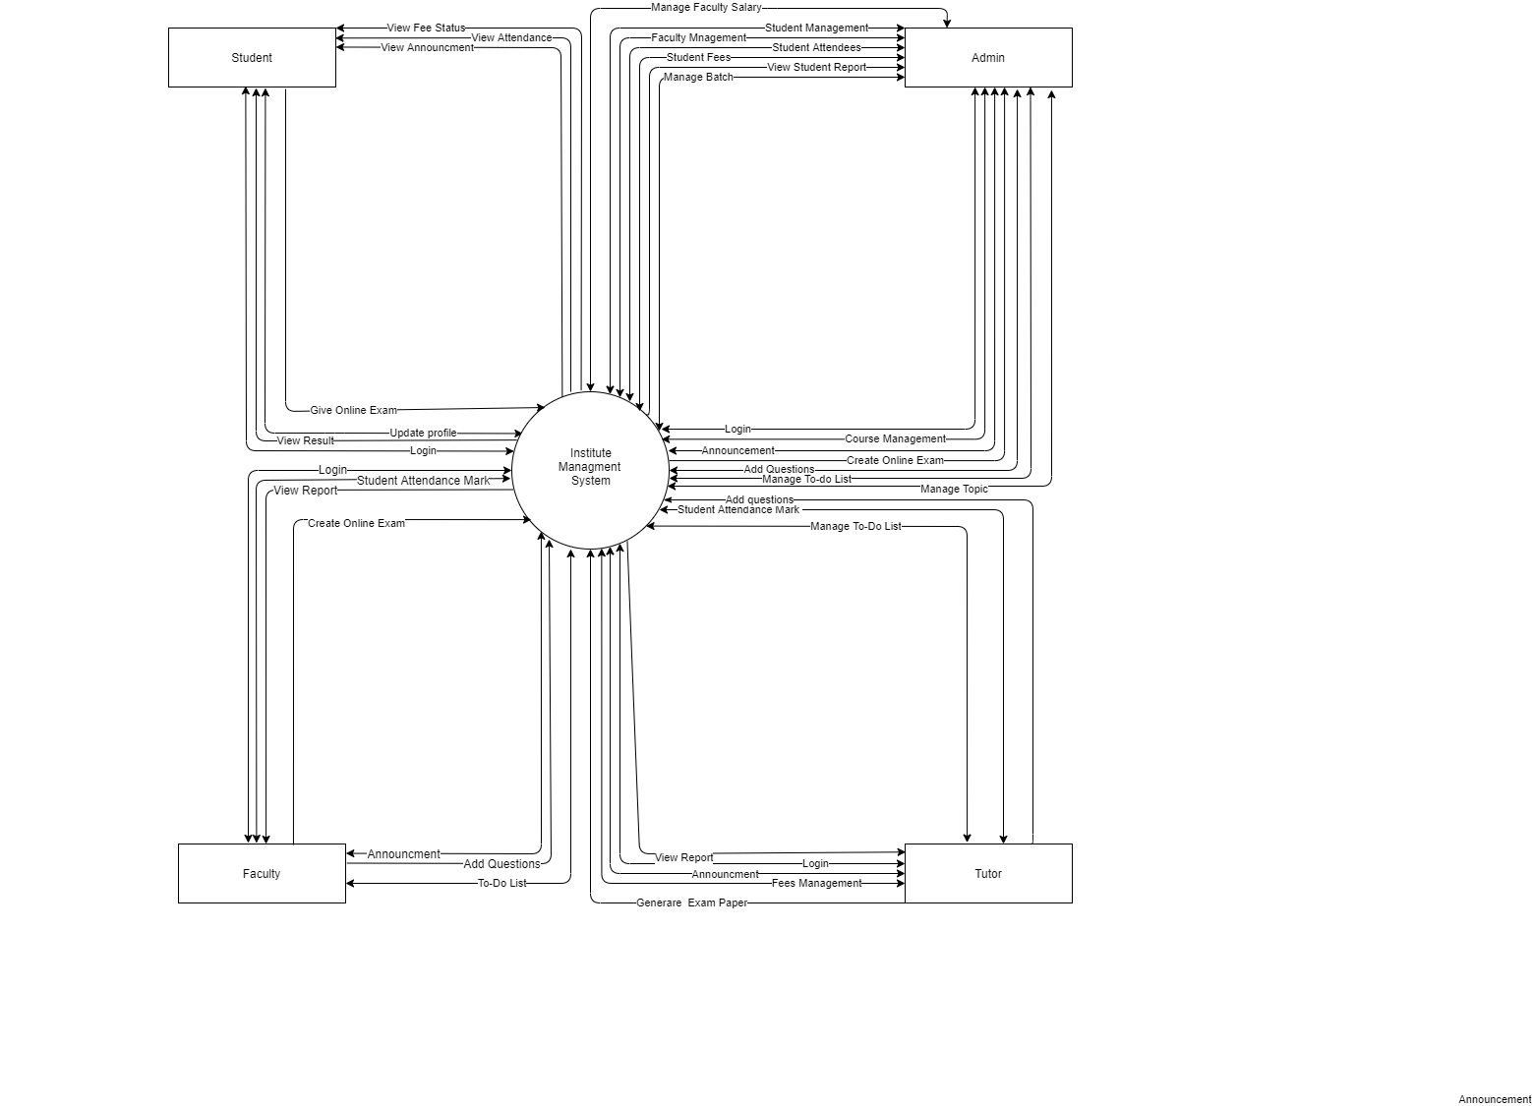

**5.3 Activity Diagram**

**5.3.1 Admin**

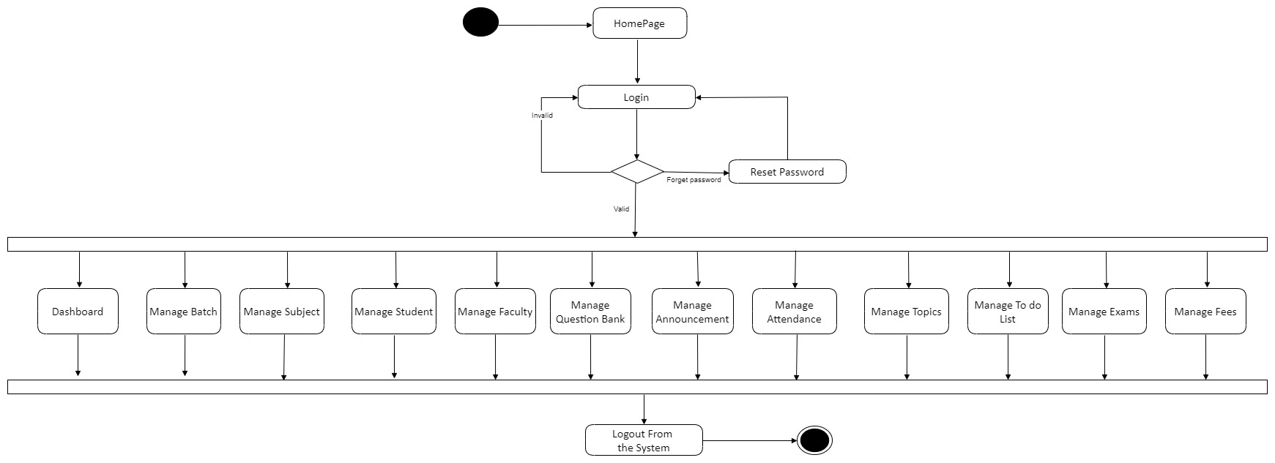

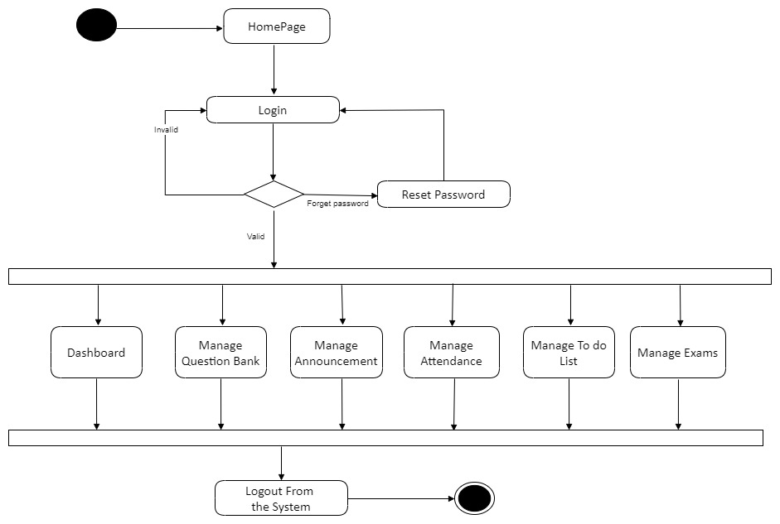**5.3.2 Faculty**

**5.3.3 Tutor**

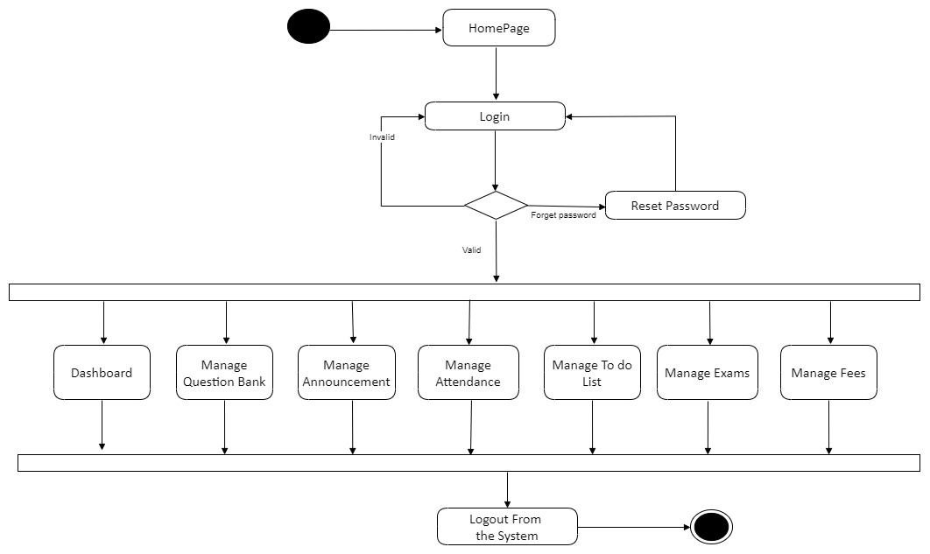

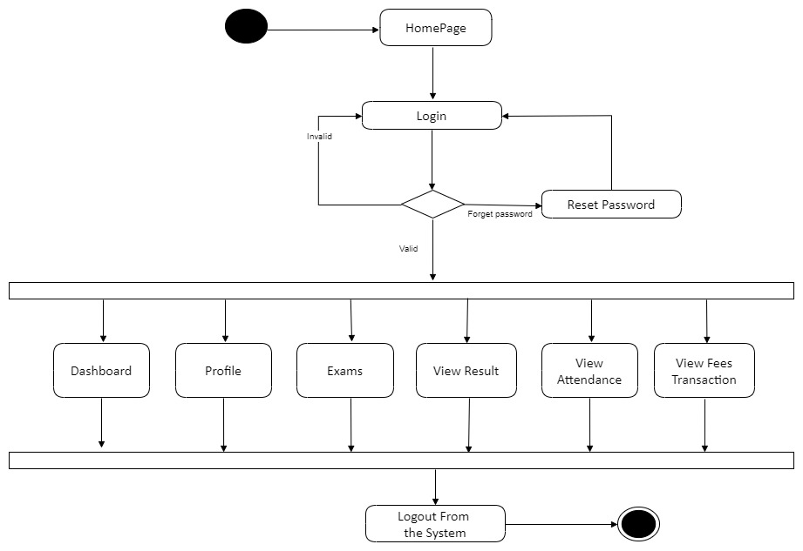**5.3.4 Student**

**5.4 Sequence Diagram**

**5.4.1 Login**

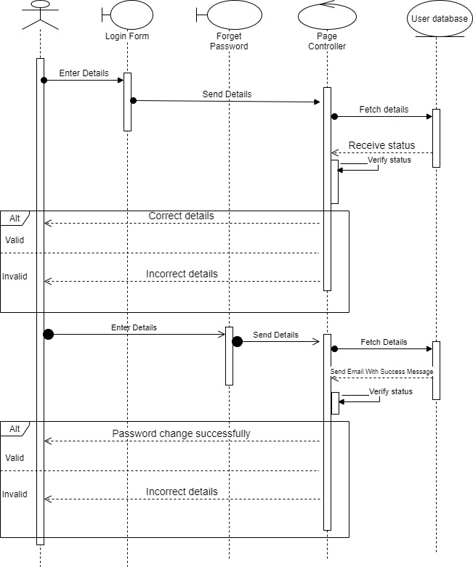

**5.4.2 Student Management**

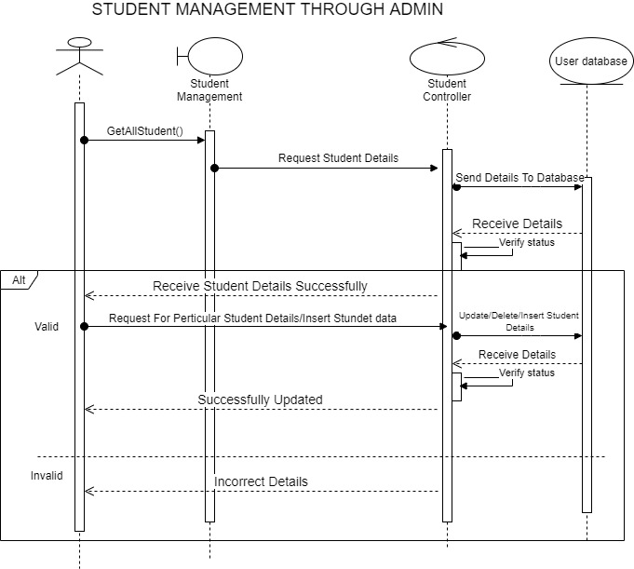

**5.4.3 Faculty Management**

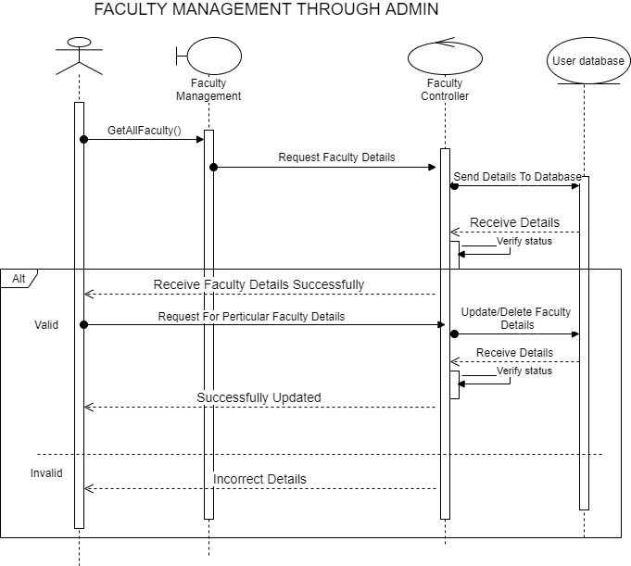

**5.4.4 Fees Management**

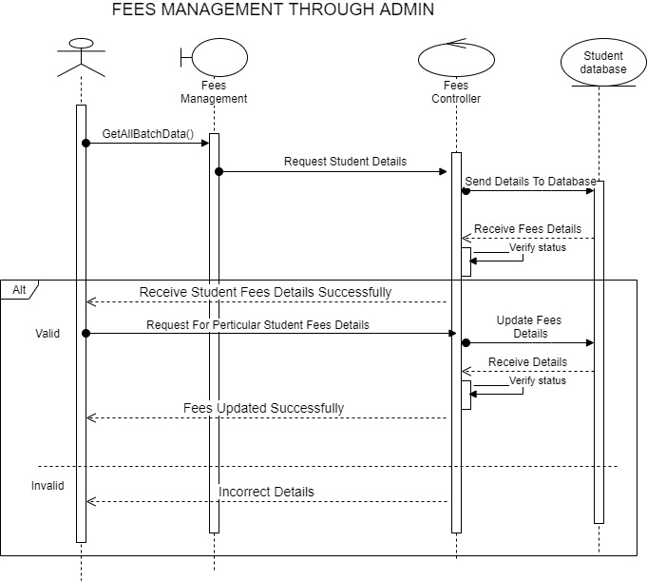

**5.4.5 Batch Management**

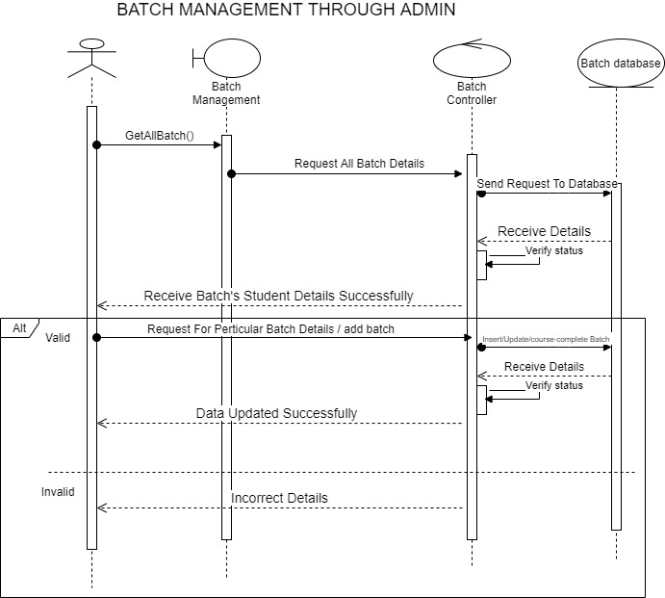

**5.4.6 Admin/Faculty/Tutor**

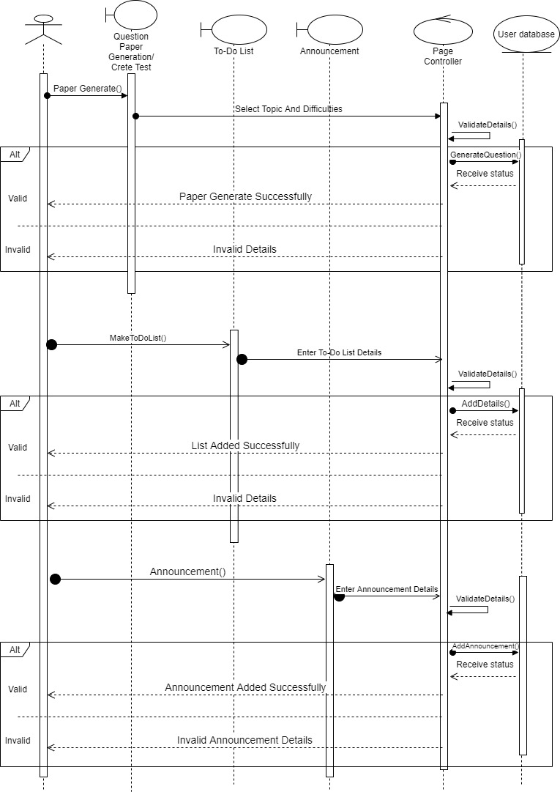

**6. Data Dictionary : arham_education**

**Table Name: - announcement**

**Description: - Stores announcements.**

**Primary Key: - Announcement_id**

**(Announcement_id Auto_Increment)**

|  |  |  |  |  |
| --- | --- | --- | --- | --- |
| **Column** | **Type** | **Null** | **Default** | **Comments** |
| Announcement_id *(Primary)* | int(11) | No |  |  |
| Title | varchar(20) | No |  |  |
| Announcemnet | varchar(500) | No |  |  |
| Date | date | No |  |  |
| Batch_id | int(11) | No |  |  |
| Faculty_id | int(11) | No |  |  |

**Table Name: - attendance**

**Description: - Stores attendance of the students.**

**Primary Key: - Announcement_id**

**Unique Key: - (Student_id, Date) (Combine) (Reason: Attendance is taken only once a day for student)**

|  |  |  |  |  |
| --- | --- | --- | --- | --- |
| **Column** | **Type** | **Null** | **Default** | **Comments** |
| Attendence_id *(Primary)* | int(11) | No |  |  |
| Date | date | No |  |  |
| Student_id | int(11) | No |  |  |
| Status | tinyint(1) | No |  |  |

**Table Name: - batch**

**Description: - Stores Batches.**

**Primary Key: - Batch_id**

**Unique Key: - Batch_name (Reason: No two batches can have same name)**

|  |  |  |  |  |
| --- | --- | --- | --- | --- |
| **Column** | **Type** | **Null** | **Default** | **Comments** |
| Batch_id (Primary) | int(11) | No |  |  |
| Batch_name | varchar(10) | No |  |  |

**Table Name: - exam**

**Description: - Stores exams information.**

**Primary Key: - Exam_id**

**Unique Key : - (Exam_name, Batch_id) (Combine) (Reason: Exam name must be unique for a batch)**

|  |  |  |  |  |
| --- | --- | --- | --- | --- |
| **Column** | **Type** | **Null** | **Default** | **Comments** |
| Exam_id *(Primary)* | int(11) | No |  |  |
| Exam_name | varchar(20) | No |  |  |
| Batch_id | int(11) | No |  |  |
| Date | date | No |  |  |
| Marks | int(11) | No |  |  |
| Time | int(11) | No |  |  |
| Faculty_id | int(11) | No |  |  |

**Table Name: - faculty**

**Description: - Stores Faulty information.**

**Primary Key: - Faculty_id**

**Unique Key: - Mobile_no, Email_id (Reason: Mobile_no & Email_id must be unique)**

|  |  |  |  |  |
| --- | --- | --- | --- | --- |
| **Column** | **Type** | **Null** | **Default** | **Comments** |
| Faculty_id *(Primary)* | int(11) | No |  |  |
| Name | varchar(50) | No |  |  |
| Mobile_no | varchar(10) | No |  |  |
| Email_id | varchar(50) | No |  |  |
| Password | varchar(250) | No |  |  |
| Date_of_birth | date | No |  |  |
| Salary | int(11) | No |  |  |
| Qualification | varchar(50) | No |  |  |
| Role | int(11) | No |  |  |

**Table Name: - fee**

**Description: - Stores fees transaction information.**

**Primary Key: - Transaction_id**

|  |  |  |  |  |
| --- | --- | --- | --- | --- |
| **Column** | **Type** | **Null** | **Default** | **Comments** |
| Transaction_id *(Primary)* | int(11) | No |  |  |
| Student_id | int(11) | No |  |  |
| Paid_amount | int(11) | No |  |  |
| Date | date | No |  |  |

**Table Name: - question**

**Description: - Stores Questions.**

**Primary Key: - Question_id**

|  |  |  |  |  |
| --- | --- | --- | --- | --- |
| **Column** | **Type** | **Null** | **Default** | **Comments** |
| Question_id *(Primary)* | int(11) | No |  |  |
| Tag_id | int(11) | No |  |  |
| Difficulty | int(11) | No |  |  |
| Question | varchar(4000) | No |  |  |
| Option1 | varchar(100) | No |  |  |
| Option2 | varchar(100) | No |  |  |
| Option3 | varchar(100) | No |  |  |
| Option4 | varchar(100) | No |  |  |
| Answer | varchar(100) | No |  |  |
| Count | int(11) | No |  |  |
| Faculty_id | int(11) | No |  |  |

**Table Name: - question paper**

**Description: - Stores Question Paper for exam.**

**Primary Key: - (Question_id,Exam_id) (Combine)**

|  |  |  |  |  |
| --- | --- | --- | --- | --- |
| **Column** | **Type** | **Null** | **Default** | **Comments** |
| Question_id *(Primary)* | int(11) | No |  |  |
| Exam_id *(Primary)* | int(11) | No |  |  |

**Table Name: - result**

**Description: - Stores result of students.**

**Primary Key : - (Student_exam_id,Obtained_Marks)**

|  |  |  |  |  |
| --- | --- | --- | --- | --- |
| **Column** | **Type** | **Null** | **Default** | **Comments** |
| Student_exam_id *(Primary)* | int(11) | No |  |  |
| Obtained_Marks *(Primary)* | int(11) | No |  |  |

**Table Name: - salary**

**Description: - Stores salary transaction information.**

**Primary Key: - Transaction_id**

|  |  |  |  |  |
| --- | --- | --- | --- | --- |
| **Column** | **Type** | **Null** | **Default** | **Comments** |
| Transaction_id *(Primary)* | int(11) | No |  |  |
| Faculty_id | int(11) | No |  |  |
| Paid_amount | int(11) | No |  |  |
| Date | date | No |  |  |

**Table Name: - student**

**Description: - Stores student information.**

**Primary Key: - Student_id**

**Unique Key: - Mobile_no, Email_id (Reason: Mobile number and Email-id should be unique for a student)**

|  |  |  |  |  |
| --- | --- | --- | --- | --- |
| **Column** | **Type** | **Null** | **Default** | **Comments** |
| Student_id *(Primary)* | int(11) | No |  |  |
| Password | varchar(8) | No |  |  |
| Name | varchar(30) | No |  |  |
| Batch_no | int(11) | No |  |  |
| Email_id | varchar(50) | No |  |  |
| Phone_no | varchar(10) | No |  |  |
| Last_name | varchar(20) | No |  |  |
| Middle_name | varchar(20) | No |  |  |
| Parent_name | varchar(50) | No |  |  |
| Parent_mobile_no | varchar(10) | No |  |  |
| Address | varchar(100) | No |  |  |
| Date_of_birth | date | No |  |  |
| Status | tinyint(1) | No |  |  |
| Fees | int(11) | No |  |  |
| Joining_date | date | No |  |  |
| Gender | varchar(6) | No |  |  |

**Table Name: - student_answer**

**Description: - Stores student's answers.**

**Primary Key: - (Student_exam_id,Question_id,Answer_id) (Combine)**

|  |  |  |  |  |
| --- | --- | --- | --- | --- |
| **Column** | **Type** | **Null** | **Default** | **Comments** |
| Student_exam_id *(Primary)* | int(11) | No |  |  |
| Question_id *(Primary)* | int(11) | No |  |  |
| Answer_id *(Primary)* | varchar(100) | No |  |  |

**Table Name: - student_exam**

**Description: - Stores student exams information.**

**Primary Key: - Student_exam_id**

**Unique key: - (Student_exam_id,Student_id,Email_id) (Reason:- Student can not appear for the same exam.)**

|  |  |  |  |  |
| --- | --- | --- | --- | --- |
| **Column** | **Type** | **Null** | **Default** | **Comments** |
| Student_exam_id *(Primary)* | int(11) | No |  |  |
| Student_id | int(11) | No |  |  |
| Exam_id | int(11) | No |  |  |

**Table Name: - subject**

**Description: - Stores subject information.**

**Primary Key: - Subject_id**

**Unique Key: - Subject_name (Reason: No two subjects can have same name)**

|  |  |  |  |  |
| --- | --- | --- | --- | --- |
| **Column** | **Type** | **Null** | **Default** | **Comments** |
| Subject_id *(Primary)* | int(11) | No |  |  |
| Name | varchar(20) | No |  |  |

**Table Name: - tag**

**Description: - Stores Subject's Tag information.**

**Primary Key: - Tag_id**

**Unique Key : - (Subject_id,Tag_Name) (Combine) (Reason : No two tags can have same name for a subject)**

|  |  |  |  |  |
| --- | --- | --- | --- | --- |
| **Column** | **Type** | **Null** | **Default** | **Comments** |
| Tag_id *(Primary)* | int(11) | No |  |  |
| Name | varchar(20) | No |  |  |
| Subject_id | int(11) | No |  |  |

**Table Name: - to_do_list**

**Description: - Stores Faculty, Admin, Tutor's Todo list.**

**Primary Key: - List_id**

|  |  |  |  |  |
| --- | --- | --- | --- | --- |
| **Column** | **Type** | **Null** | **Default** | **Comments** |
| List_id *(Primary)* | int(11) | No |  |  |
| Faculty_id | int(11) | No |  |  |
| Topic | varchar(100) | No |  |  |
| Status | tinyint(1) | No |  |  |

**7. Snapshots of Admin Side**

* 1. **DashBoard**

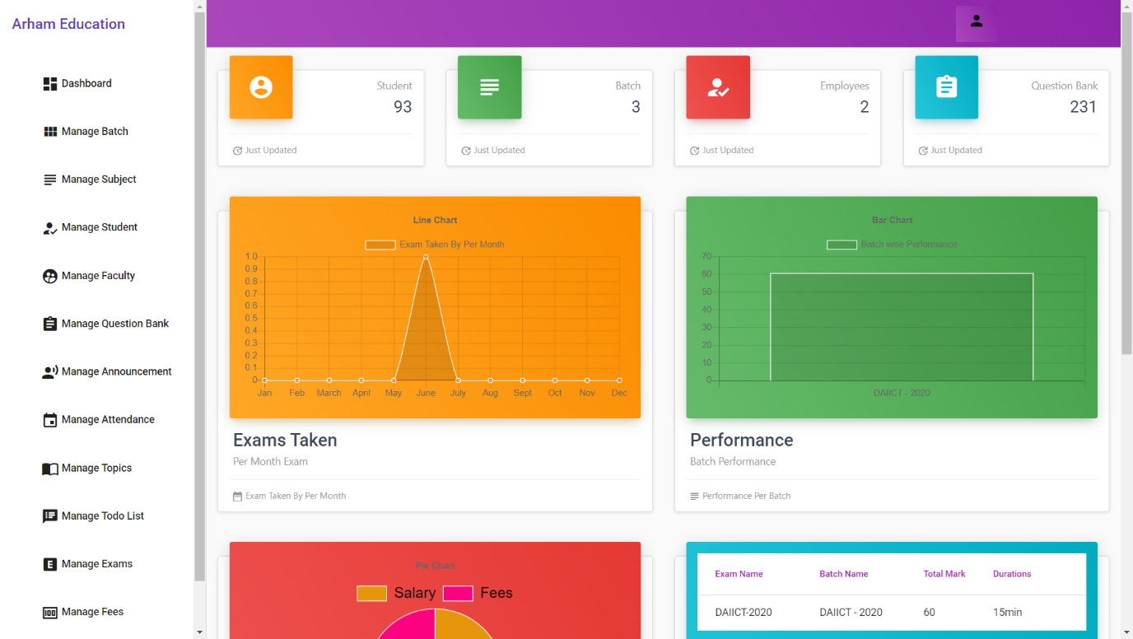

Here is Admin Module DashBoard which Shows Total Number of Students, Total Batch, Total Employees and Total Number of Questions. Below that, First Most Graph shows exams taken by the faculties. Second Chart Compares the performance of batches.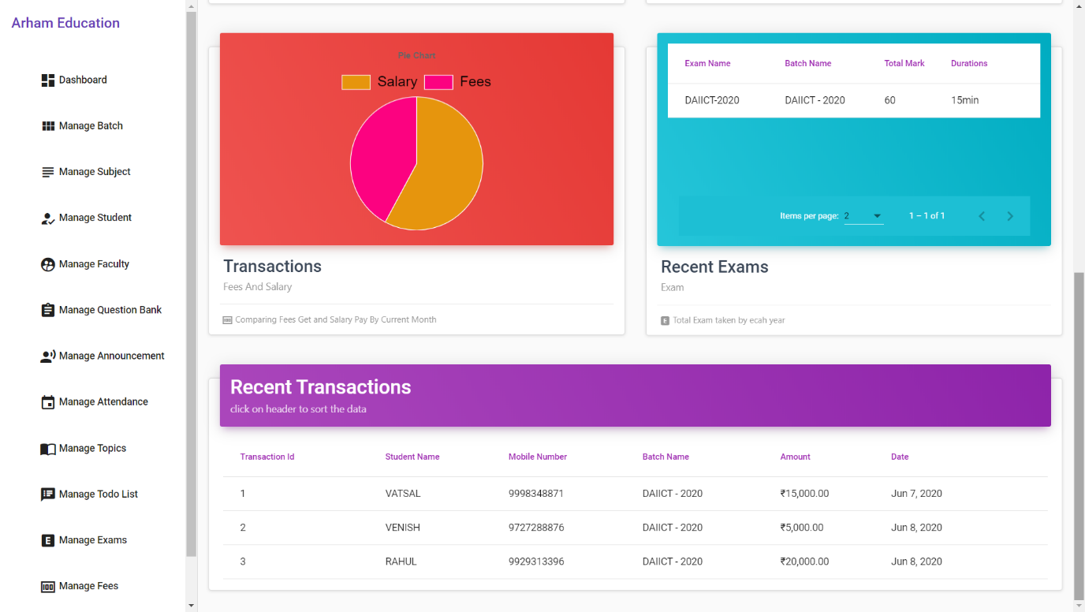

Third Transaction Pie Chart indicates the income and Expense statistics and Recent Exam Indicates the details of exam taken by institute recently.

* 1. **Batch**
     1. View Batch

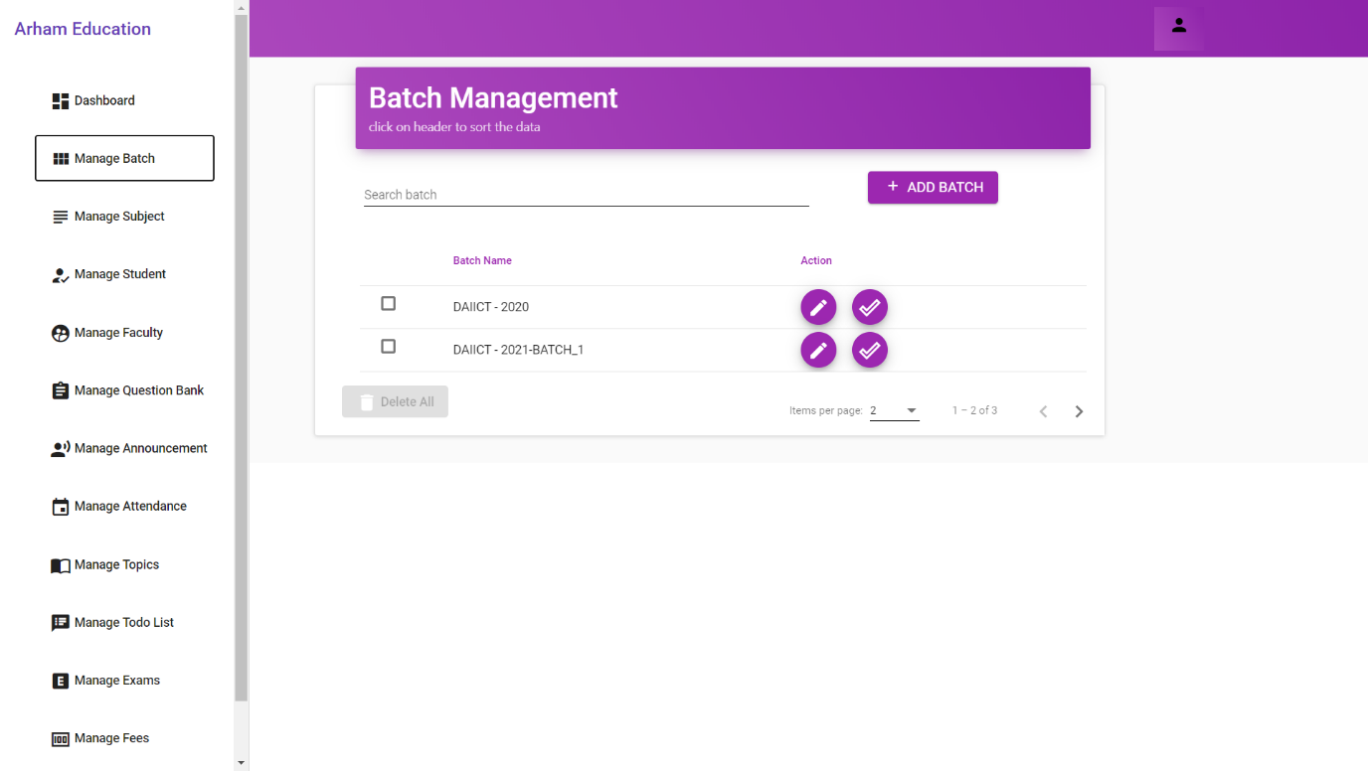

Manage Batch Tab indicates all batches listed below the search bar.

* + 1. Add Batch

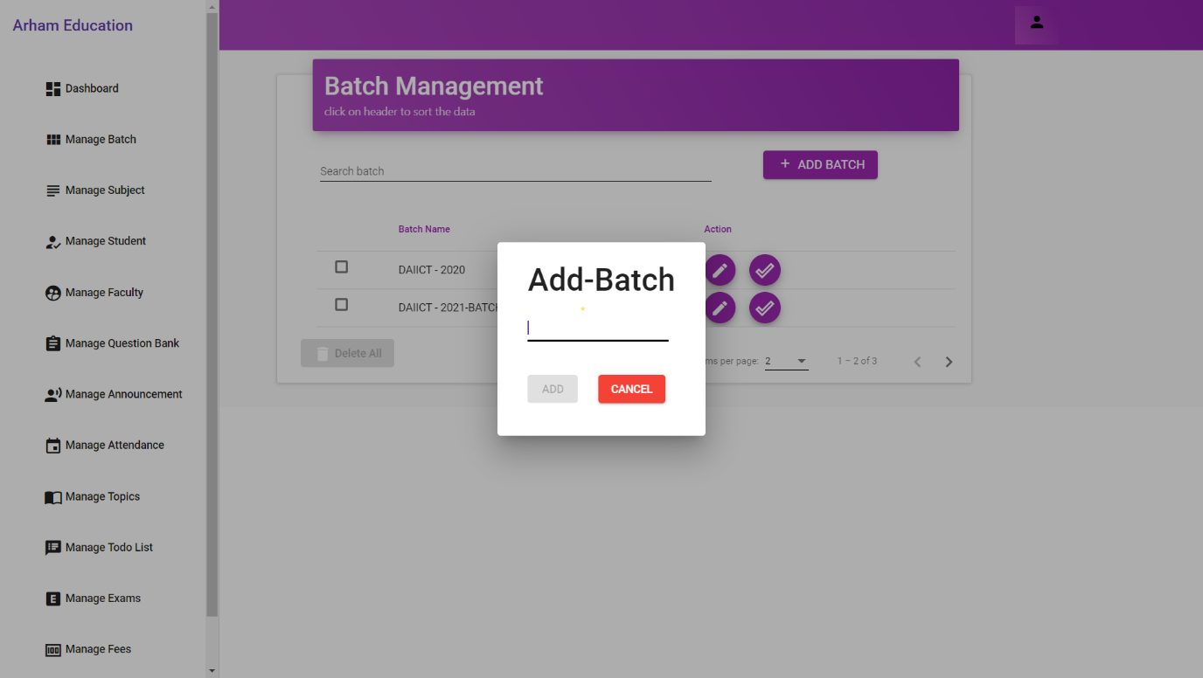

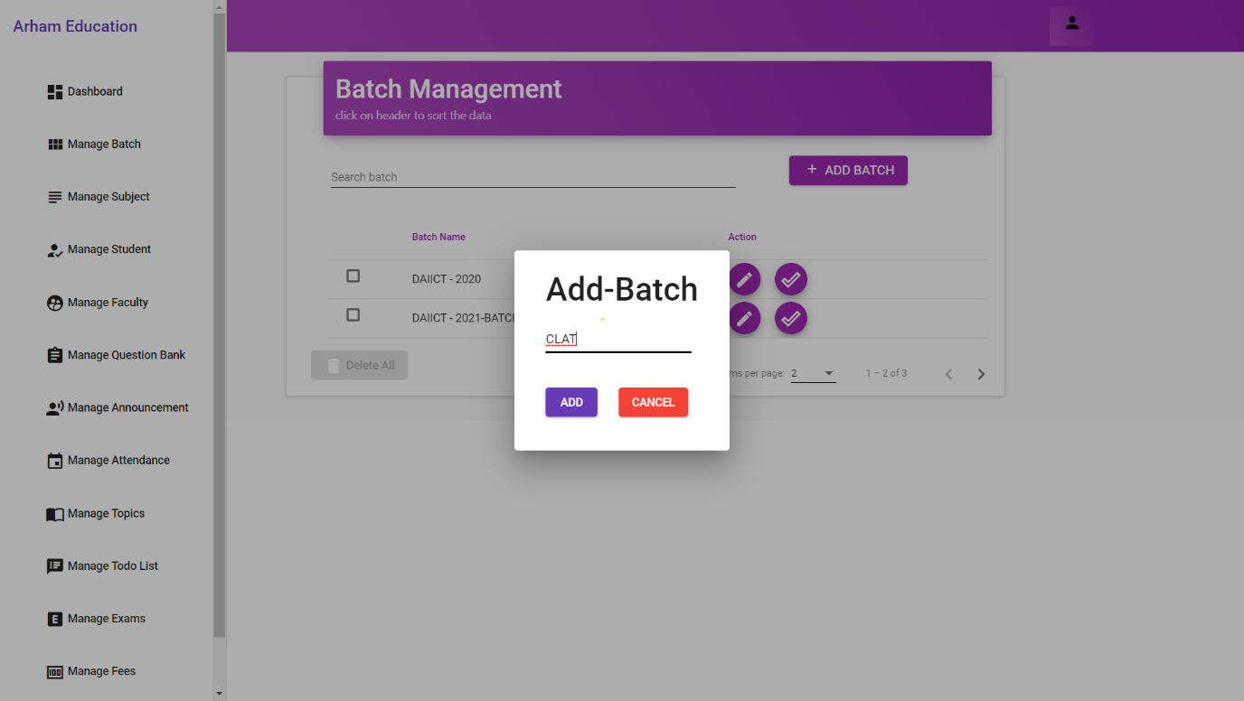

Clicking on Add Batch Button, The admin is able to add batch according to their Naming Conventions.

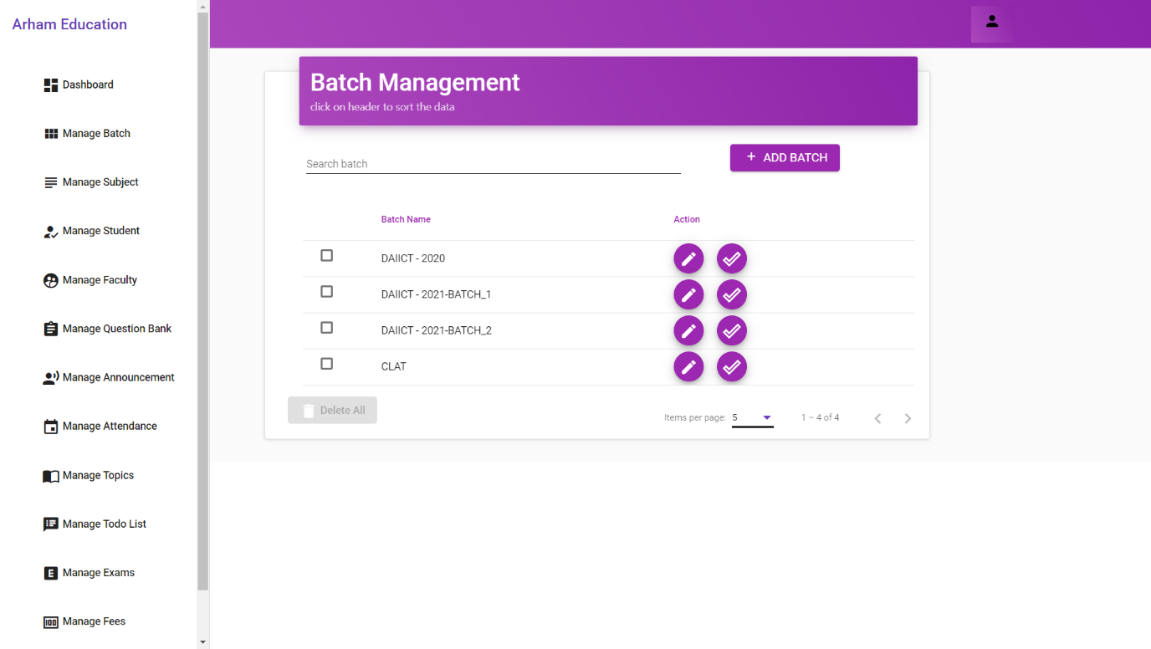

* 1. **Subject**
     1. Add Subject

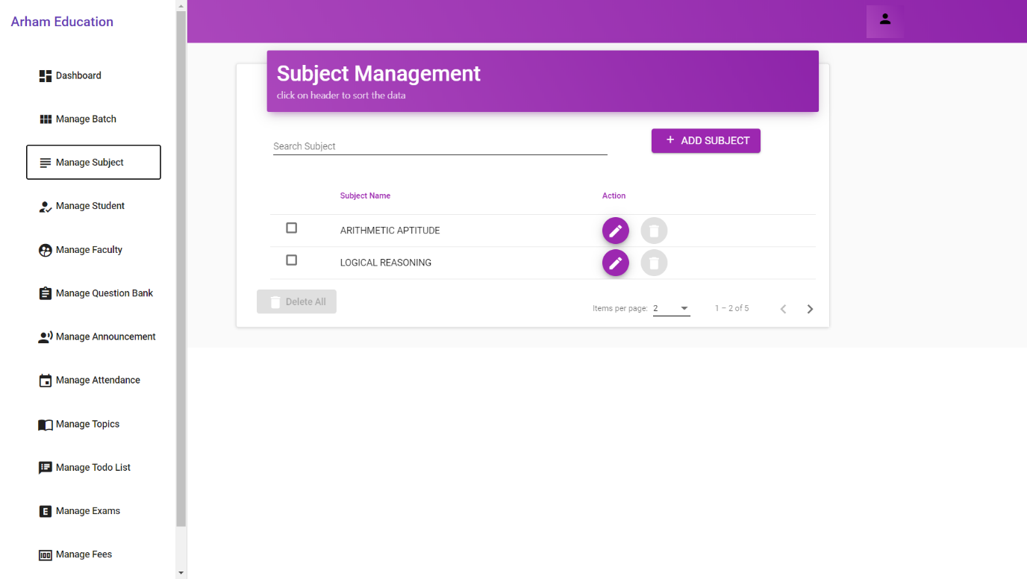

Here, Admin Can add all the subjects that are being taught at institute.

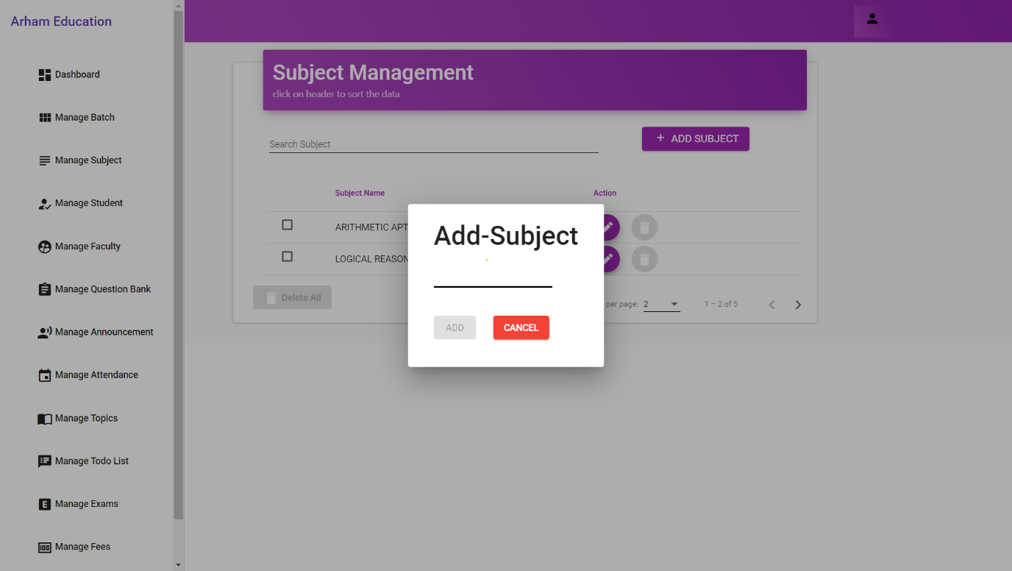

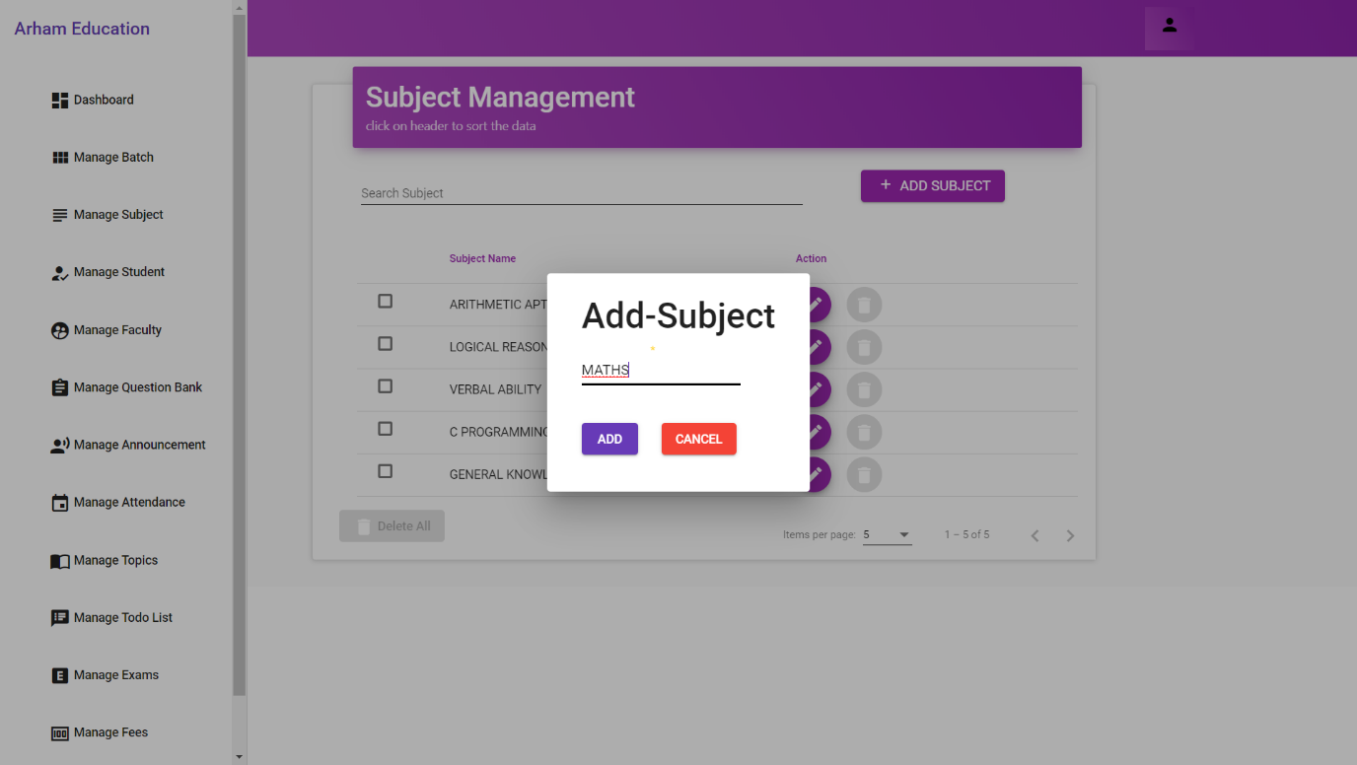

* + 1. View Subject

Once the subject is added, Admin will able to see all the subject below the search bar.

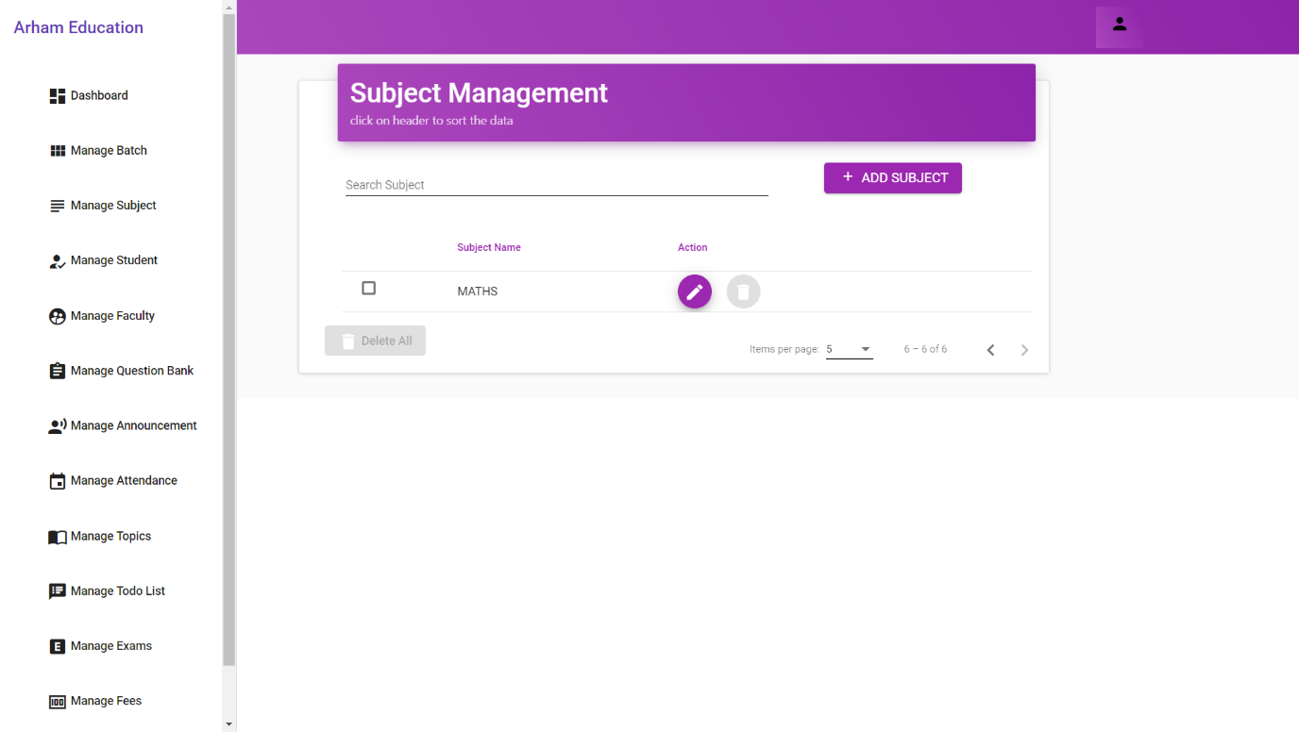

* 1. **Student**
     1. Add Student

In this tab, Admin will able to add student in the particular batch.

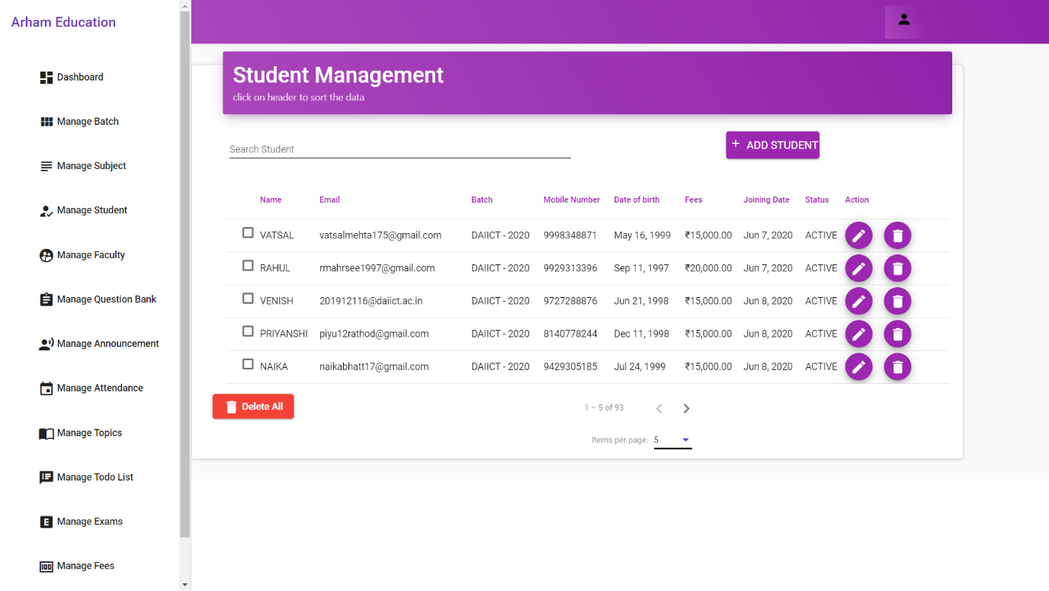

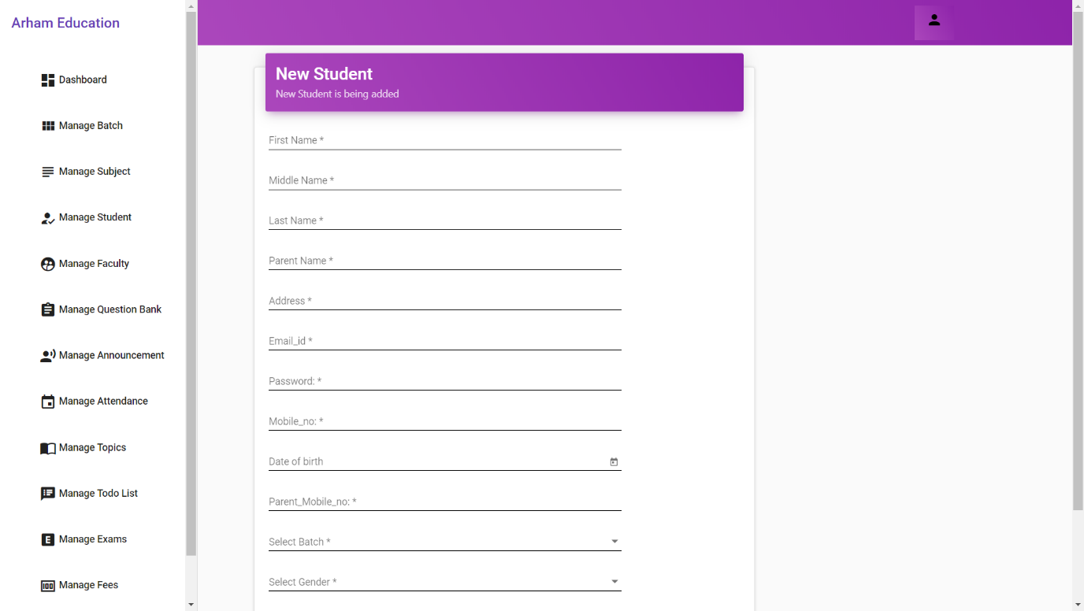

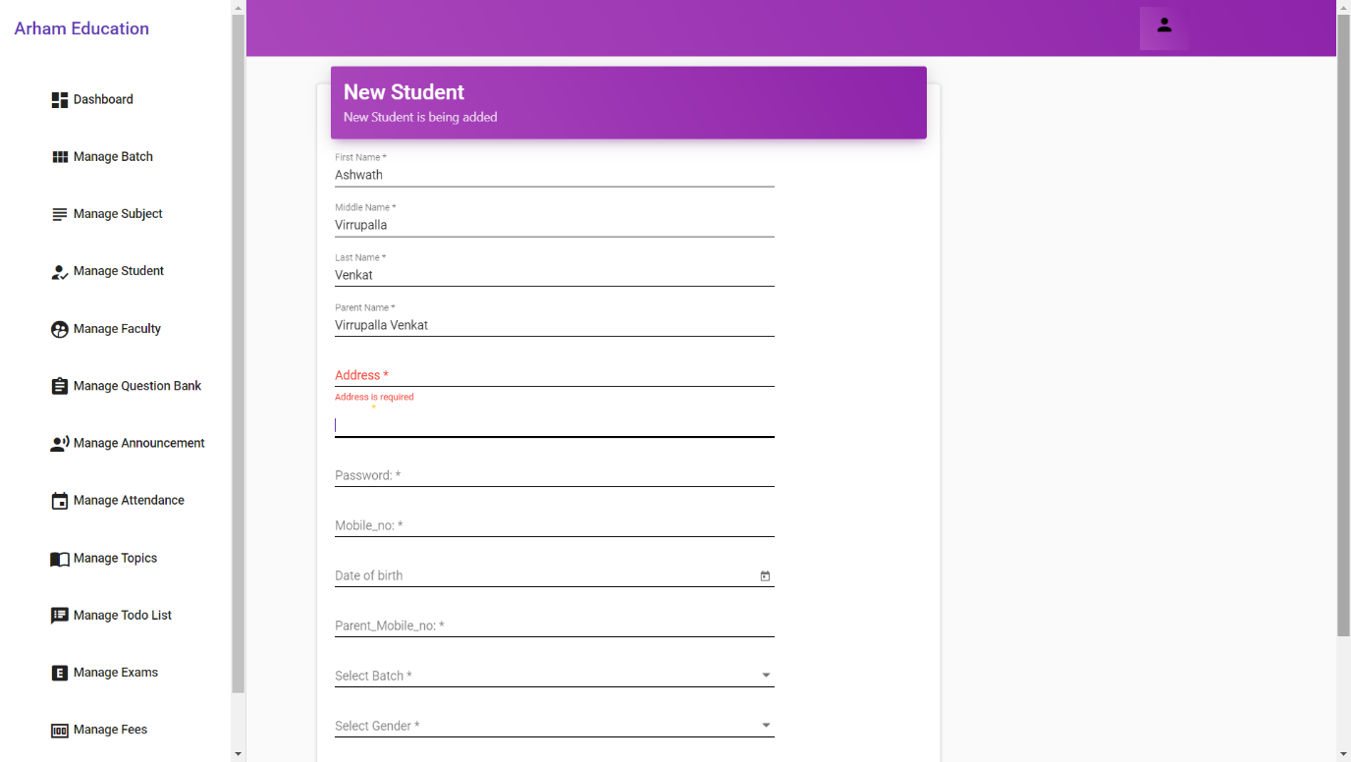

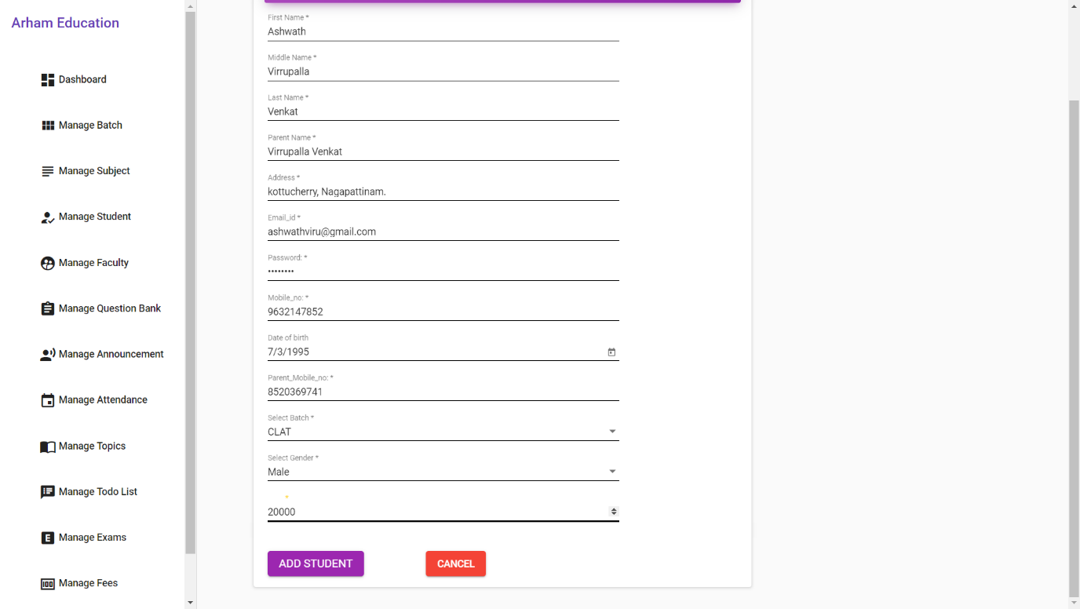

* + 1. Search Student

Admin can search particular student that he want to find.

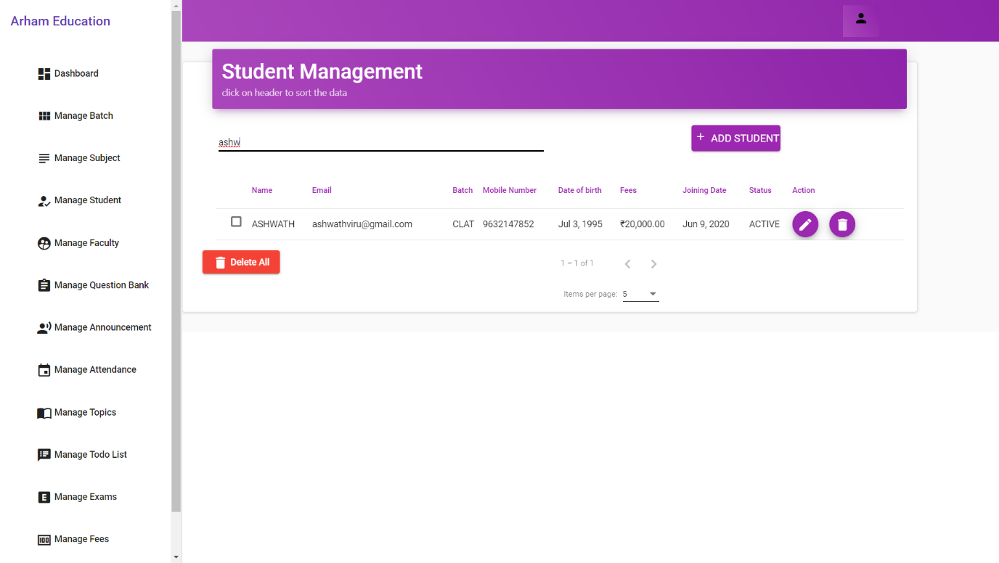

* 1. **Faculty**
     1. View Employees

Admin will find the all faculties listed below the search bar.

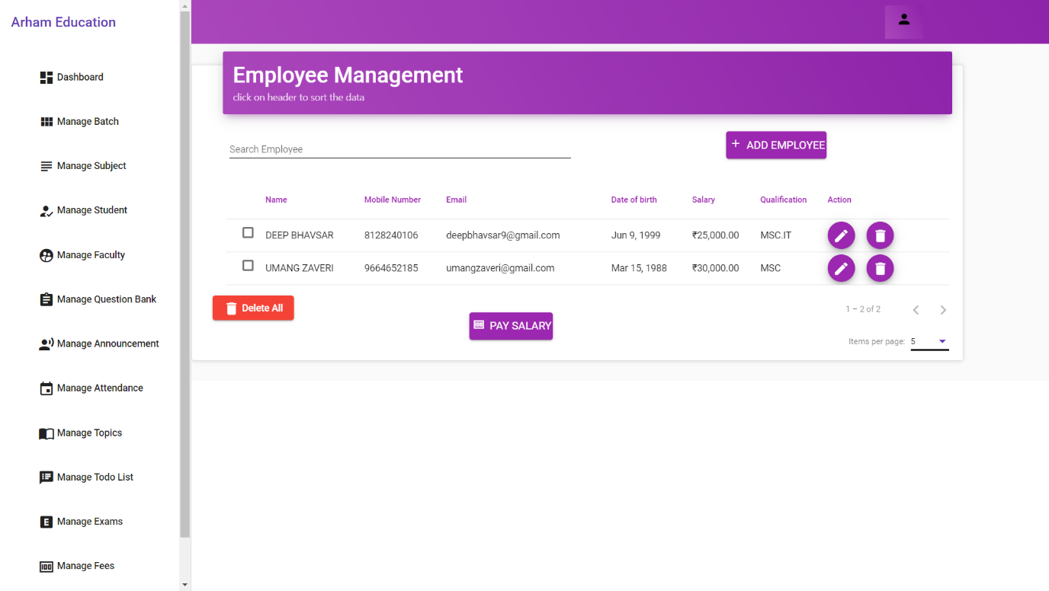

* + 1. Add Faculty/Tutor

Admin can add employees like Faculties and Tutors from here.

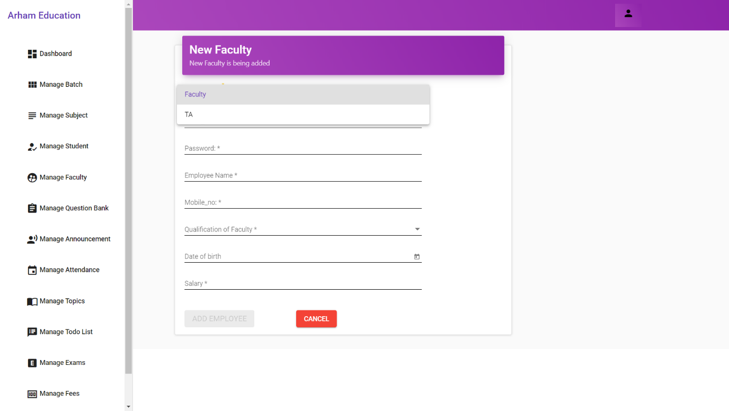

* + 1. Pay Salary of Faculty

Admin can also manage salary accounts from here

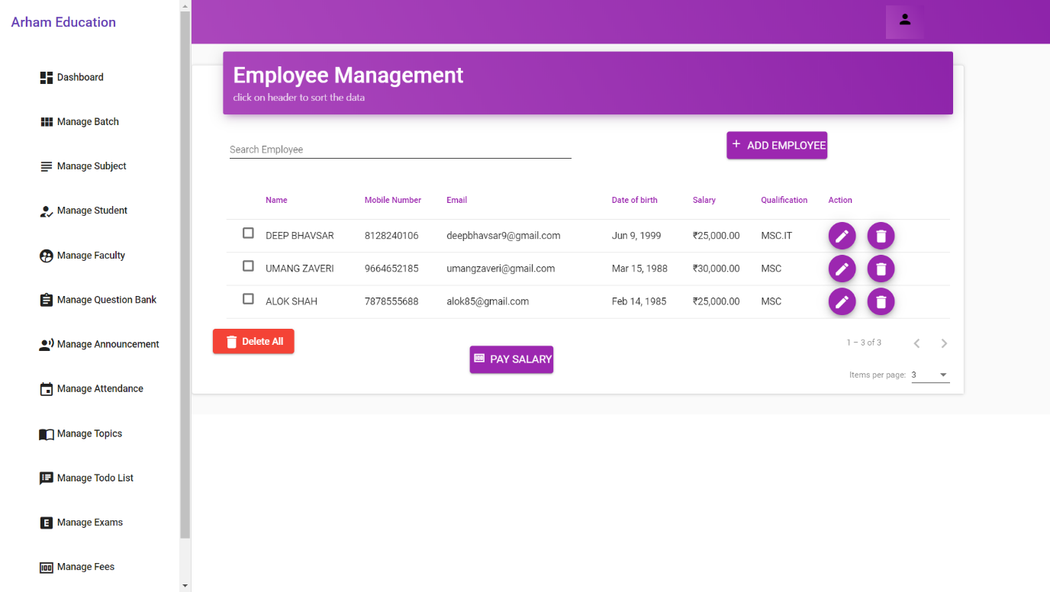

* 1. **Question Bank**
     1. View Available Questions

Here, is facility to add questions in the question bank according to need.

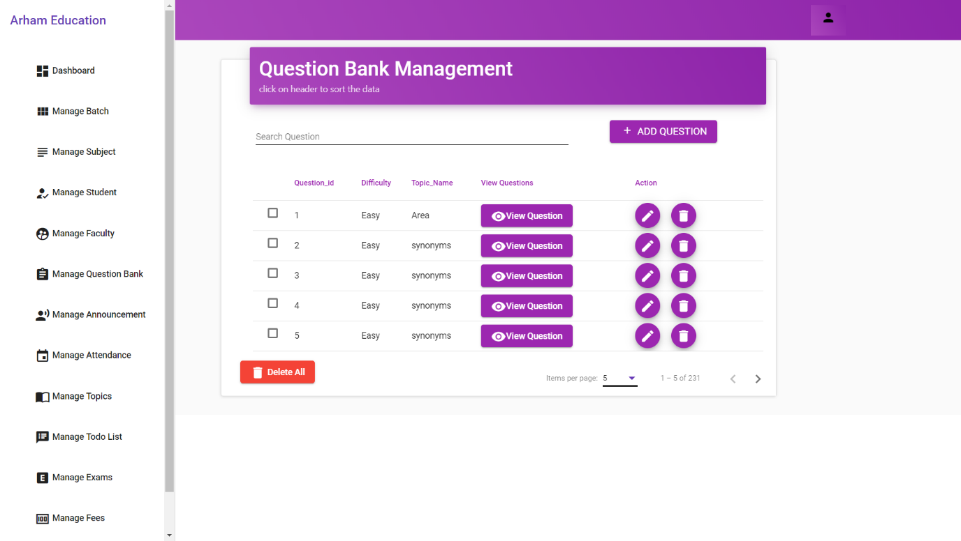

* + 1. Add Question

There are all fields availble in this section which are need including difficulty level.

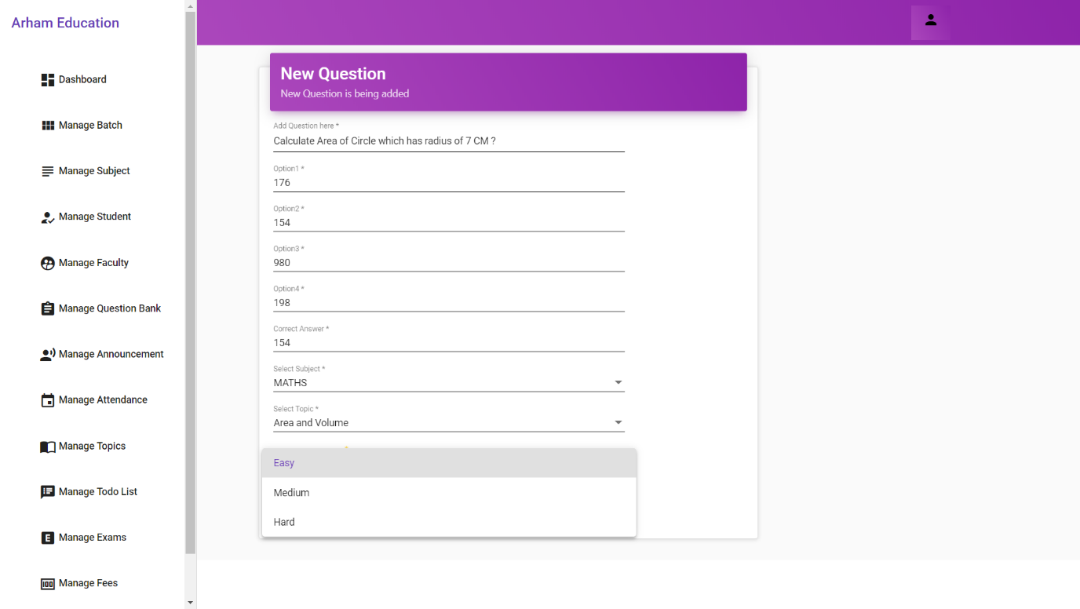

* + 1. View The Question

Admin can also view the question once he add it the question bank.

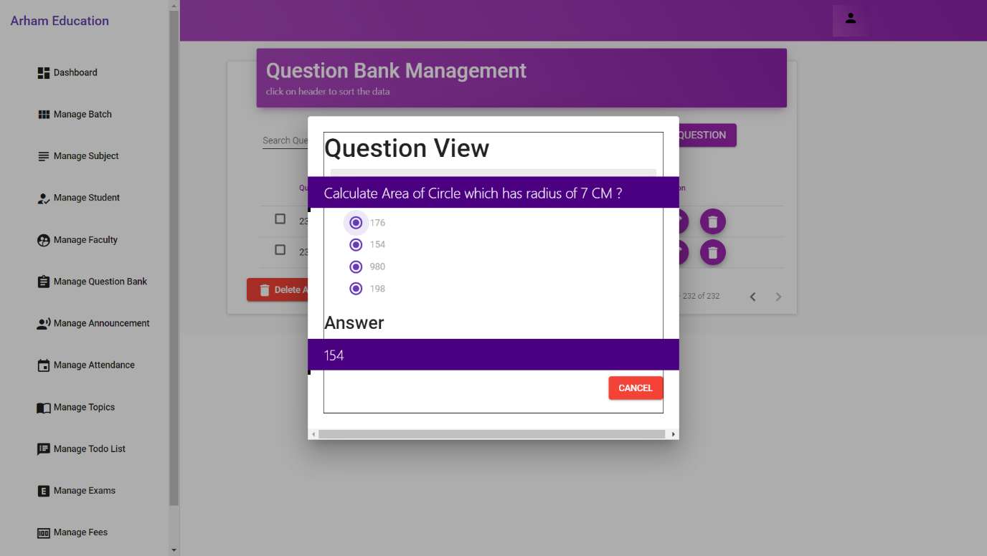

* 1. **Announcement**
     1. Add Announcement

Announcement is a facility to announce or to make notice of some reminders to student about Exams, Holidays and Pending Fees Payments

Admin have to click on add Announcemnt than have to fill the details in it.

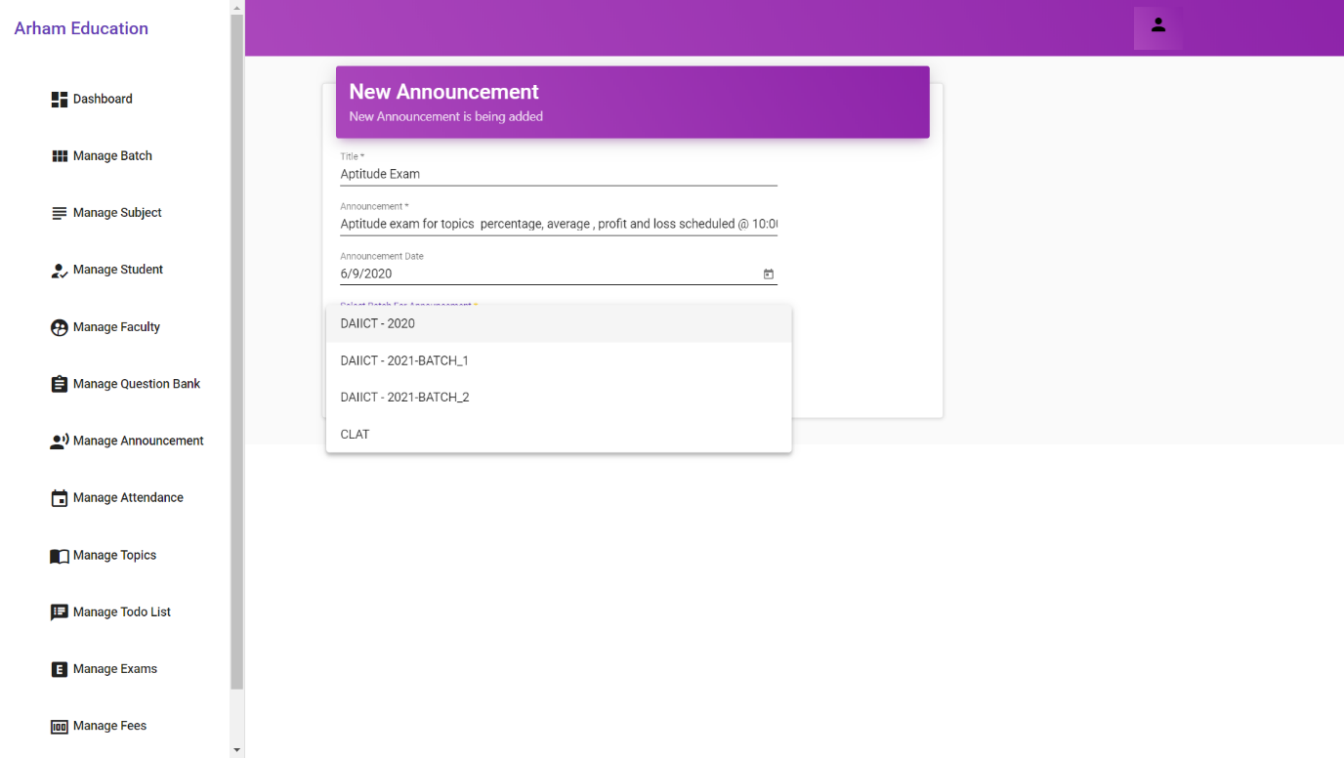

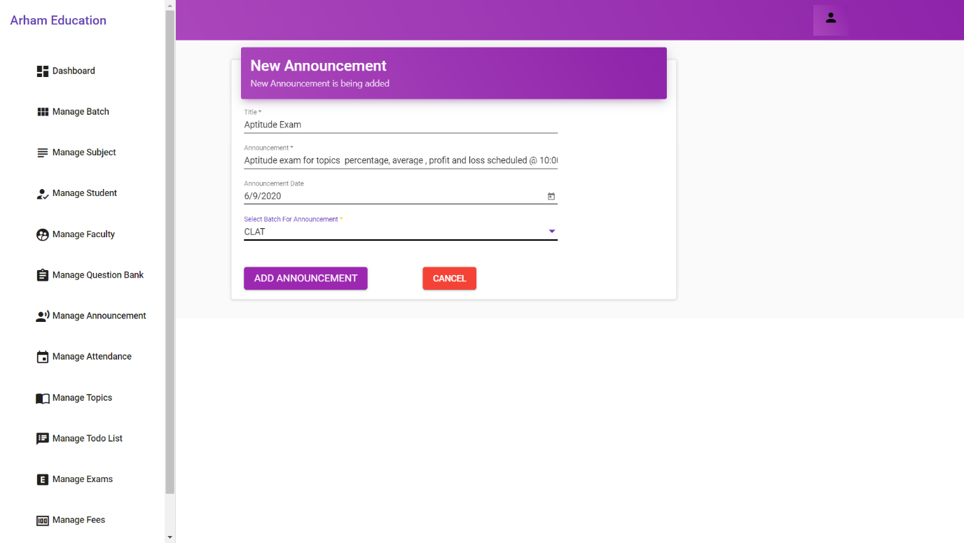

* + 1. View Announcement

Here, Admin will find all the announcement listed below the search bar.

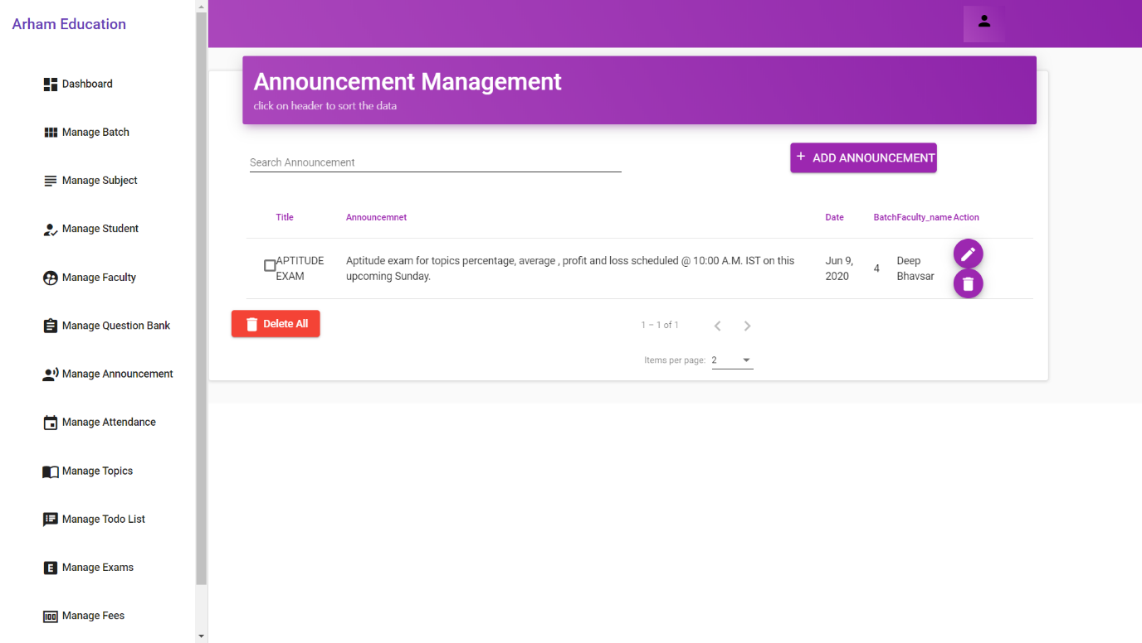

* + 1. Delete Announcement

Once the announcement is made admin can also delete announcement by clicking on delete button.

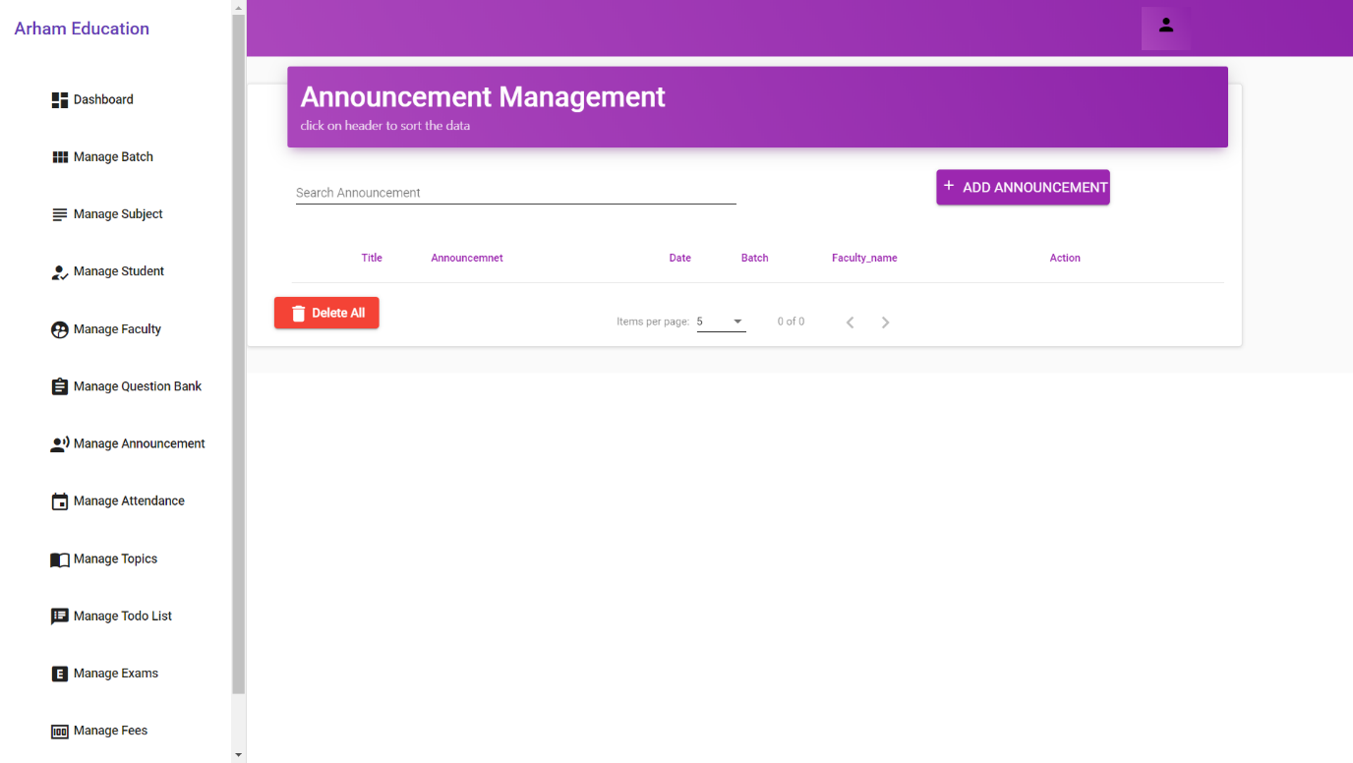

* 1. **Attendence**
     1. Select Batch and Mark Attendence

Here , Admin can take attendence of student after selecting the batch.

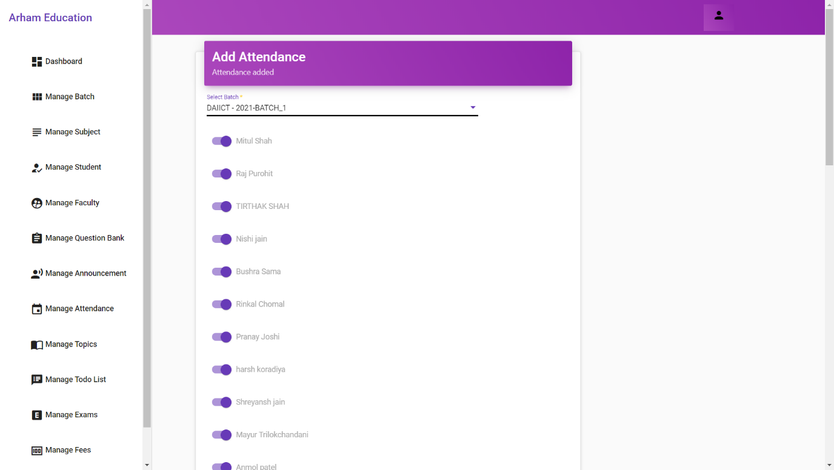

* 1. **Topics**
     1. Add Sub-Topics of Subject

Admin can also add subtopics or chapters of subject to distibute questions relating to each topic in a proper manner.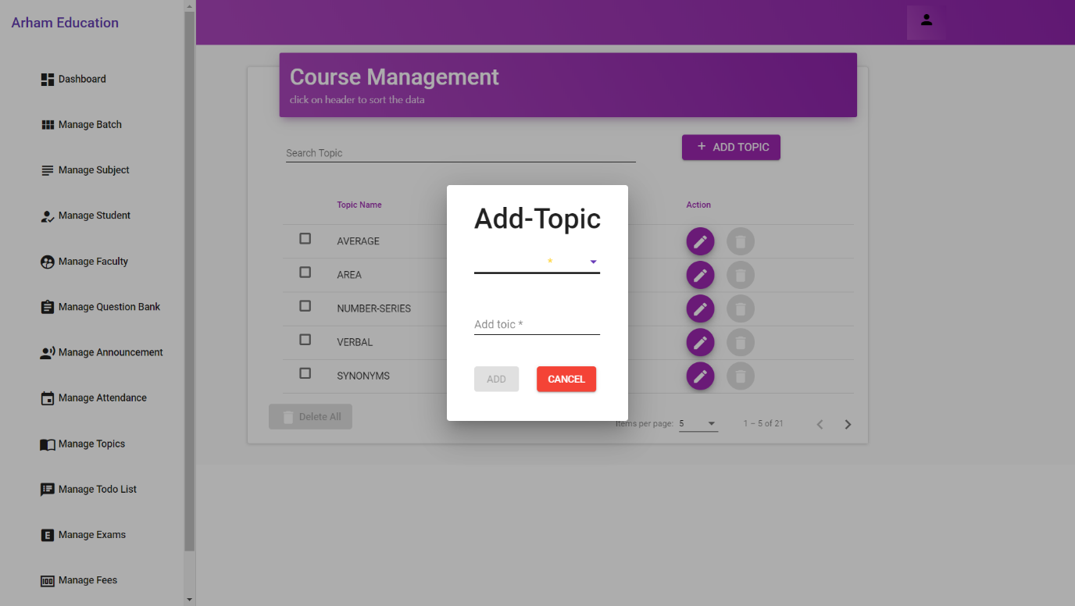

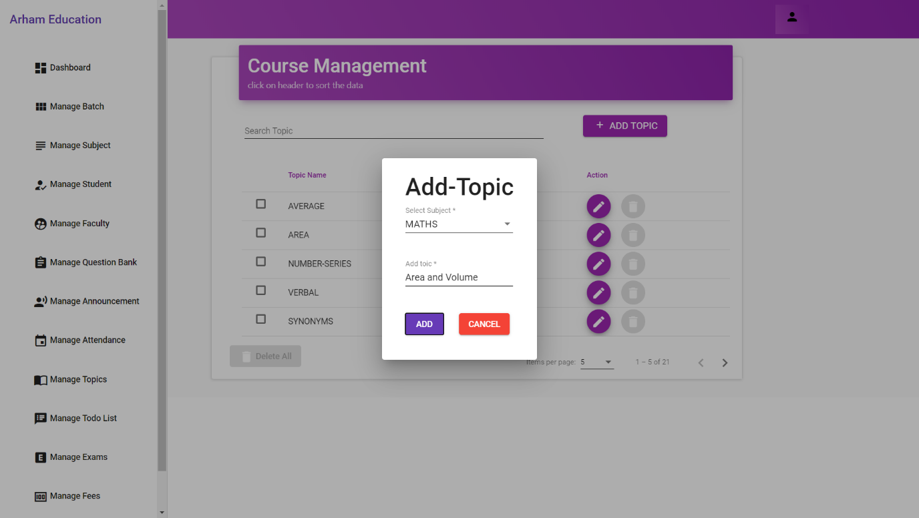

* + 1. View Sub-Topics of Subject

All the sub topic will be listed below search bar with their corresponding subjects.

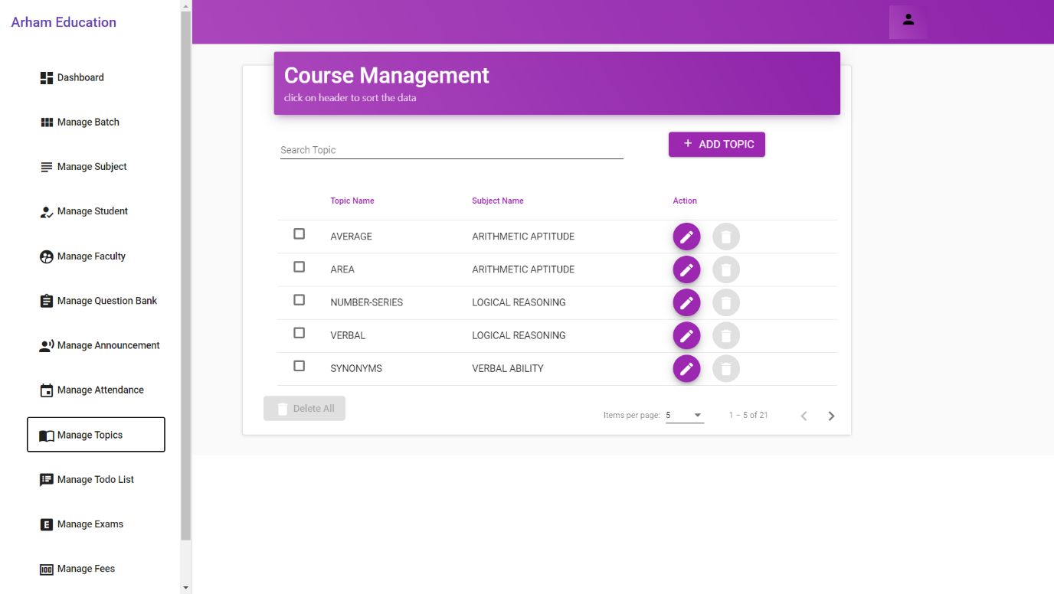

* 1. **To-Do List**
     1. Add To-Do Task

Admin can add To-Do list items here in this section.

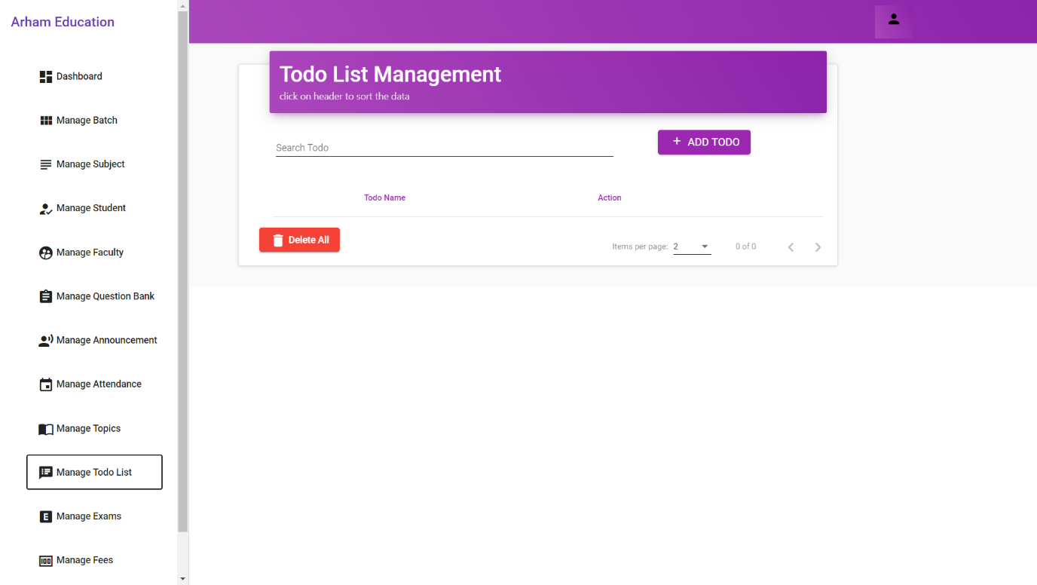

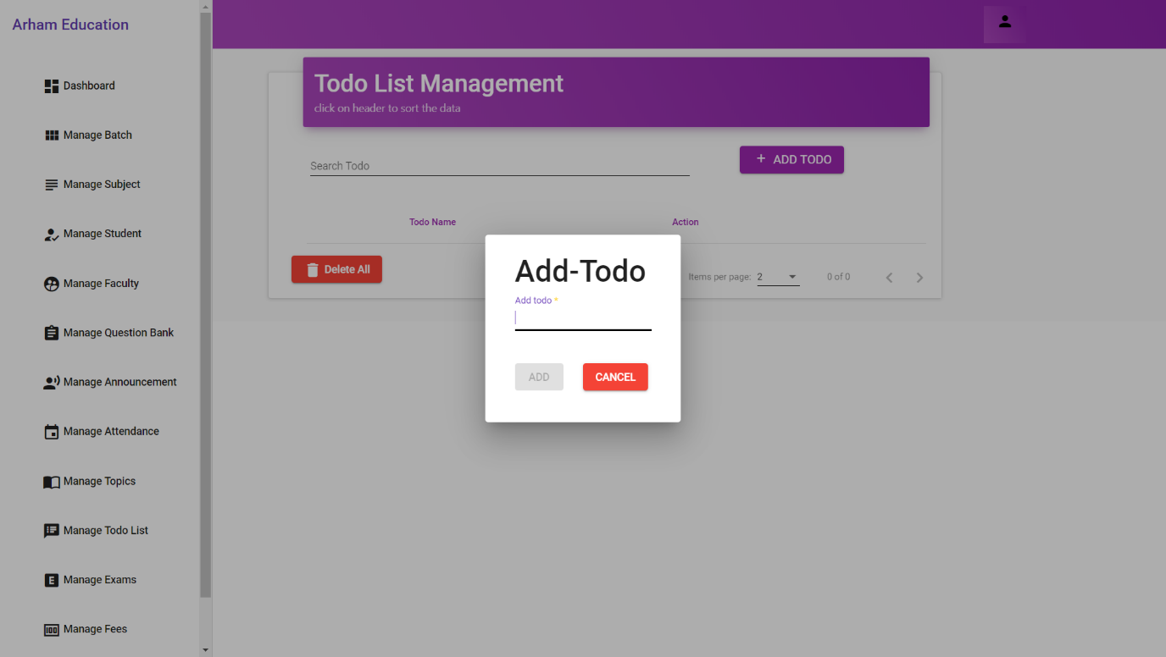

* + 1. Update To-Do Task

Admin will also able to update to-do list Item.

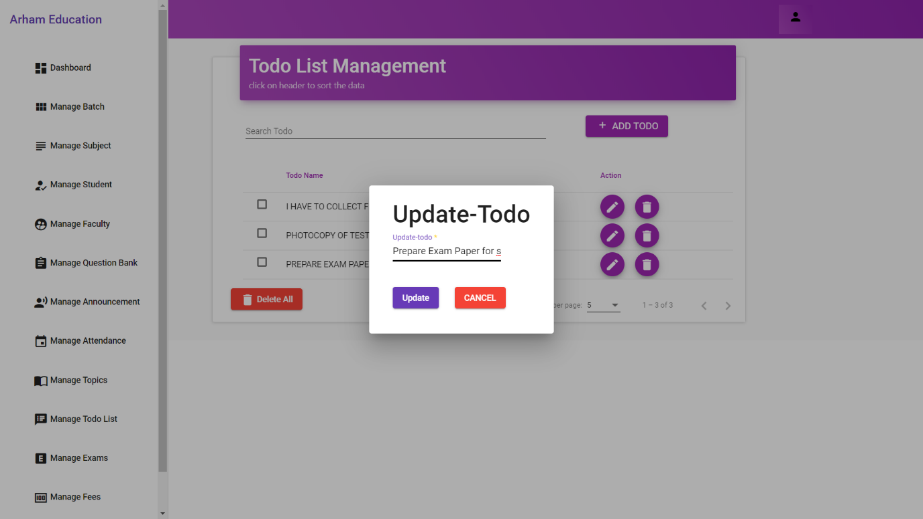

* + 1. Delete To – Do Task

Admin will also able to delete to-do list Item once the task is completed.

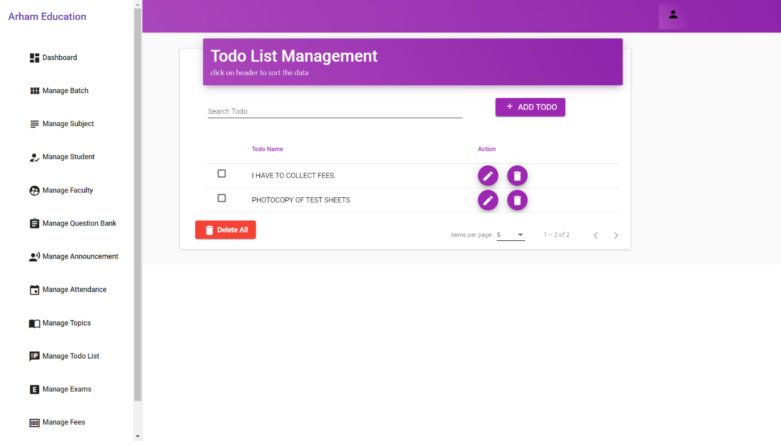

* 1. **Exam**
     1. Create Test

Here, Admin will able to create test.

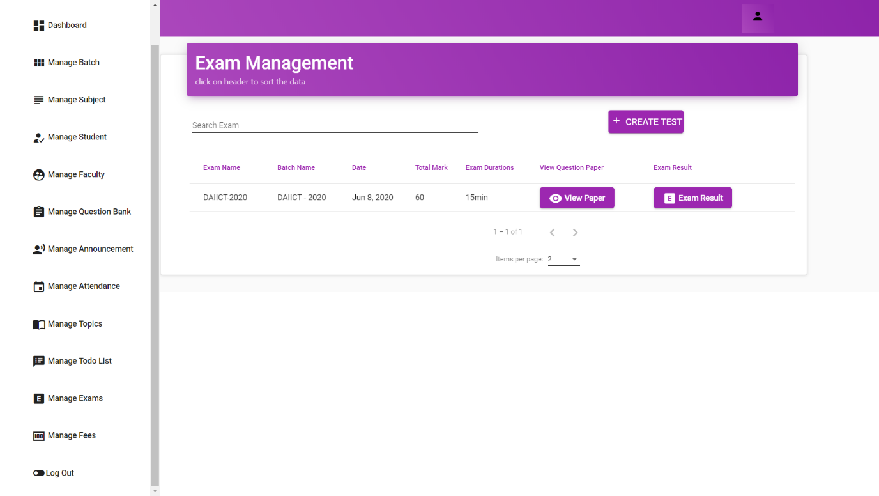

* + 1. Set Properties of Test Paper (Time,Date,Subject)

Once the create exam button is clicked it will show such input fields to set subjects , time and date of exam.

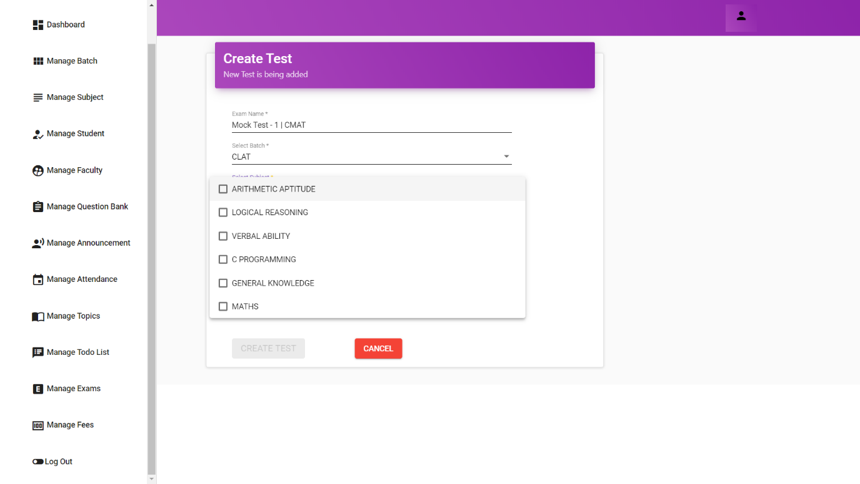

* + 1. Set Random Test

There are 2 scenerios in exam genaration random and custom. Here in random Test , System will automatically generate the test paper.

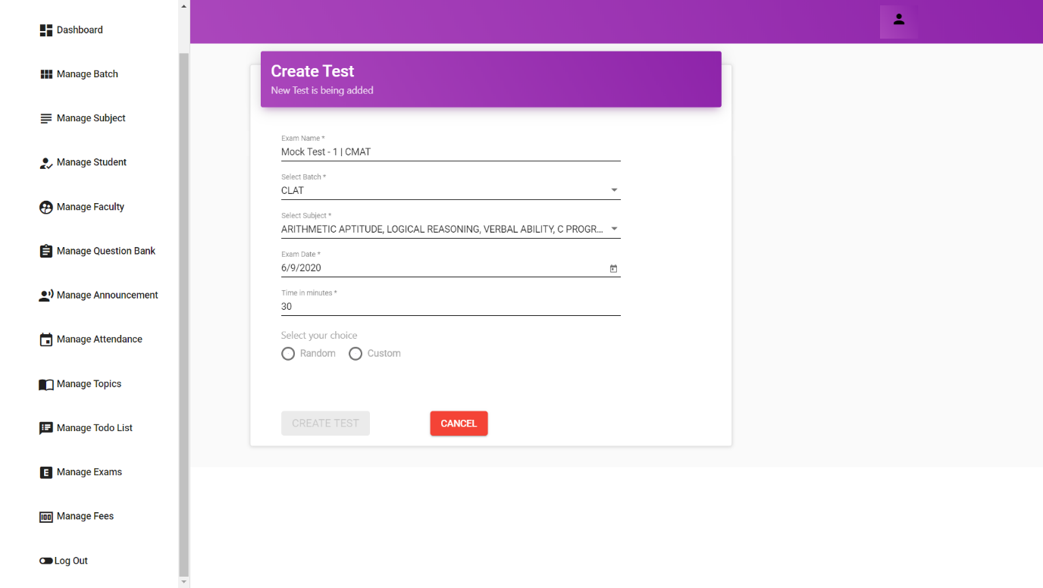

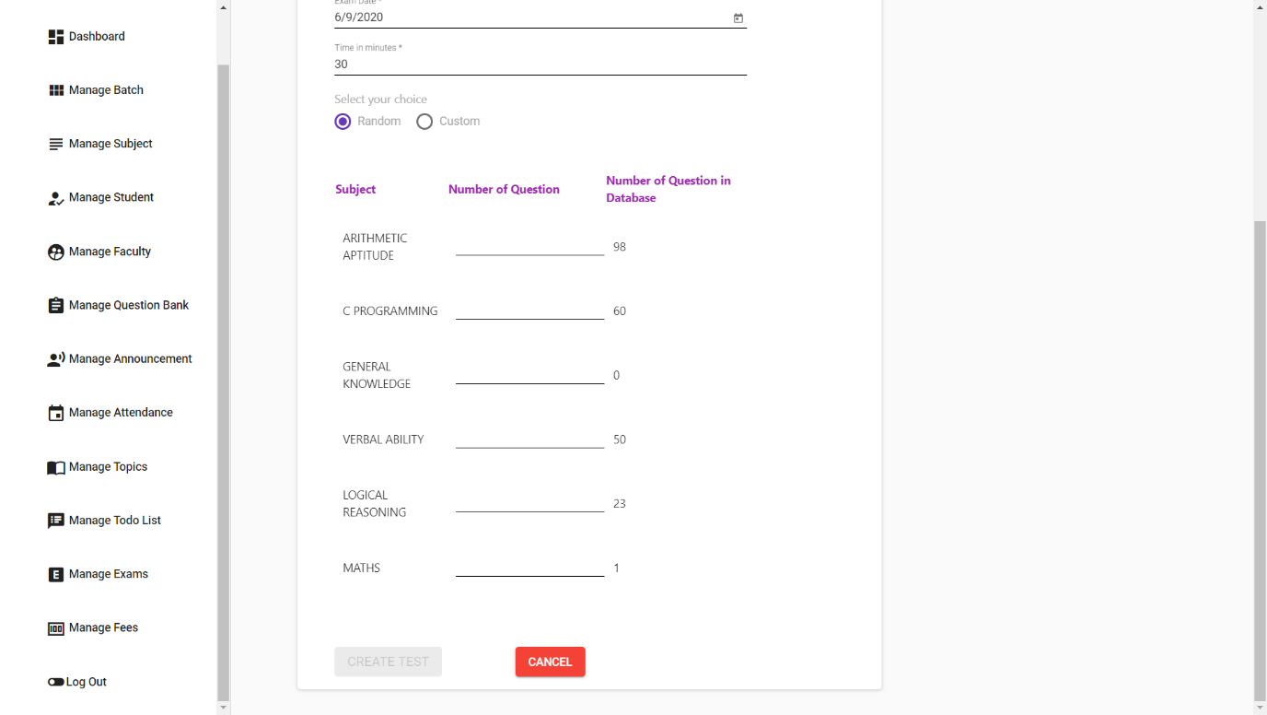

* + 1. Set Custom Difficulty Test

In custom Test paper we can select sub topics and set difficulty level of test as well.

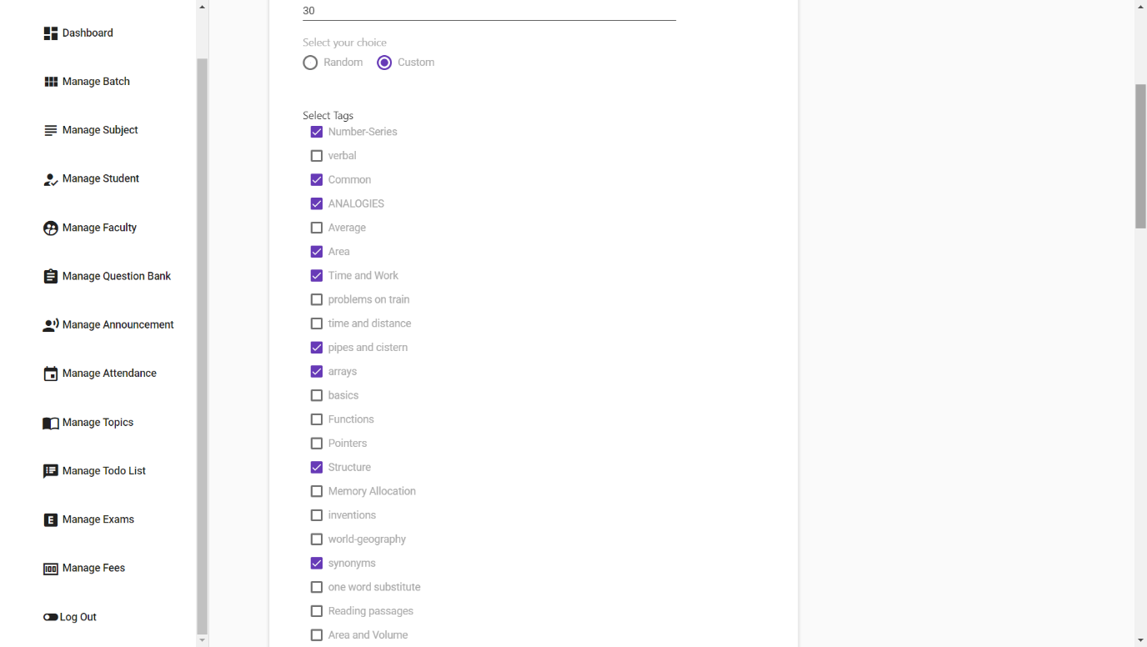

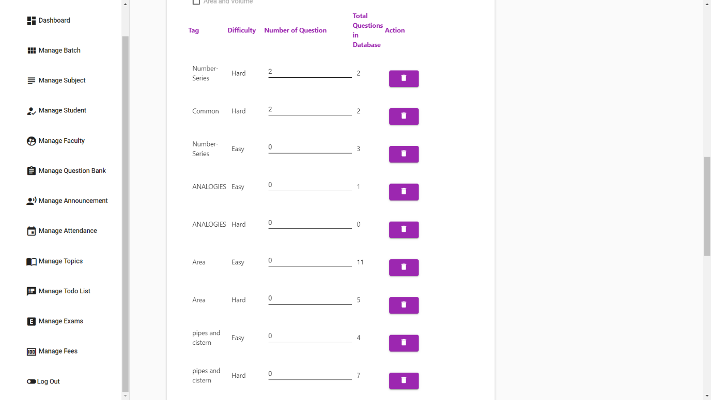

* + 1. View Exams

All the exams will be listed here.

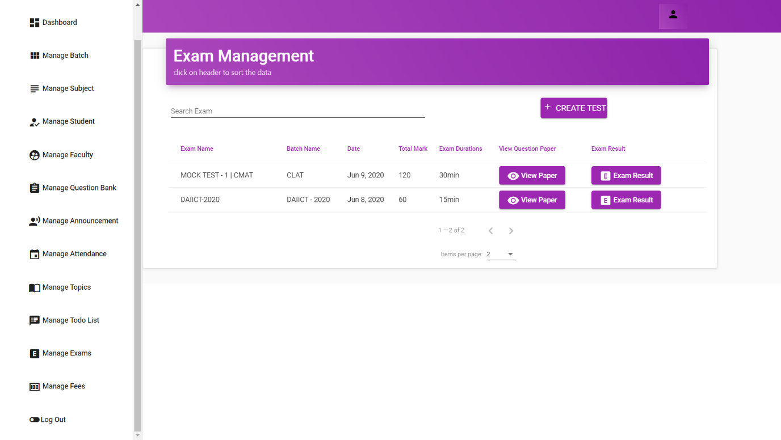

* + 1. View Question Paper

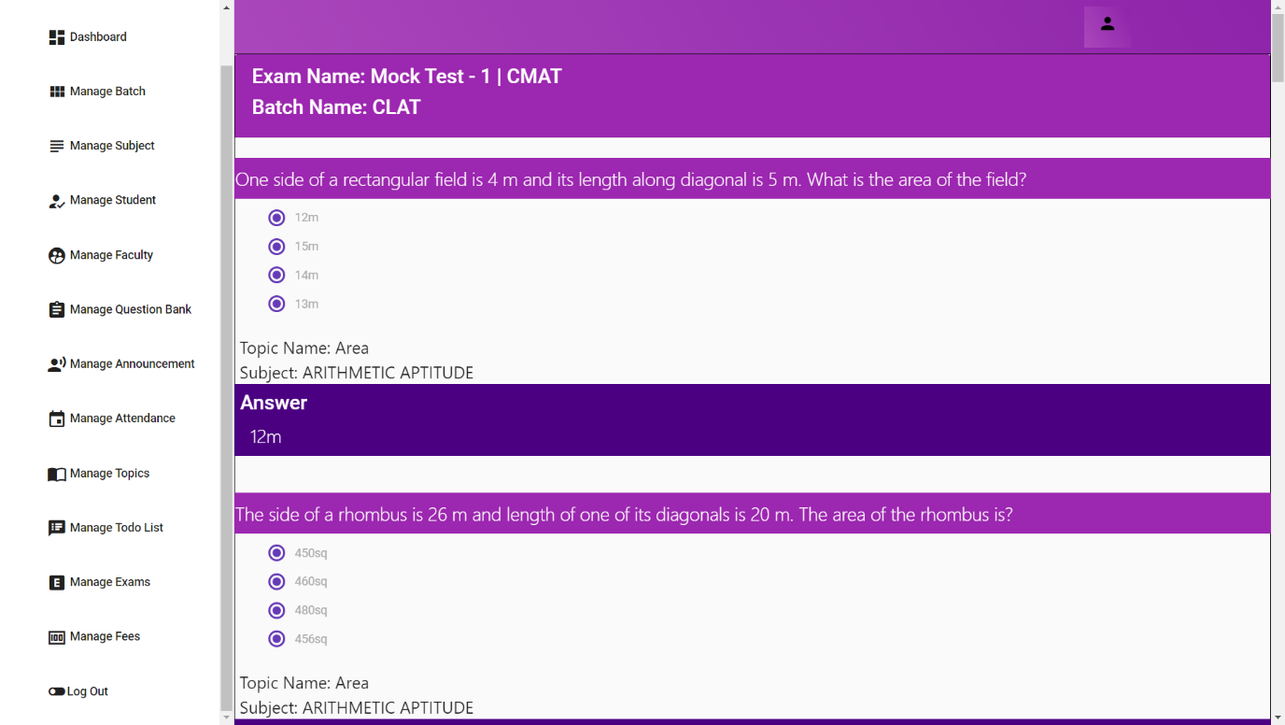

Admin can also view the question paper of the exam.

* + 1. View Results

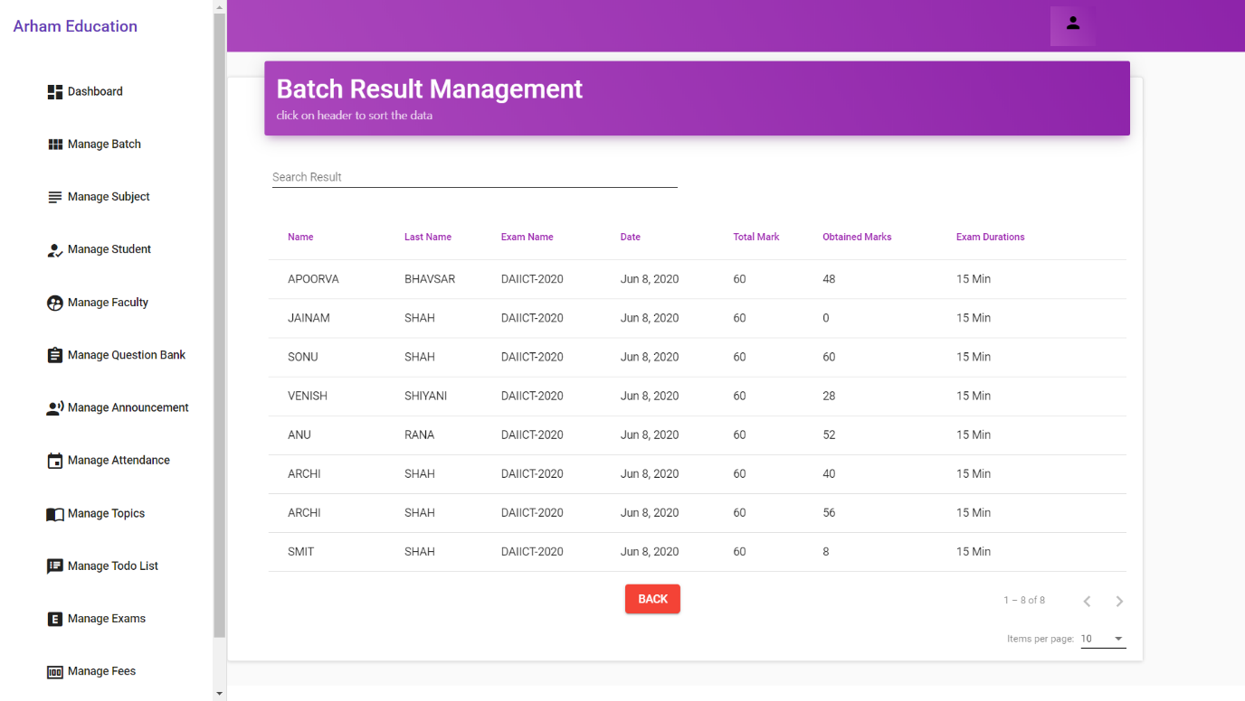

Clicking on Exam Result , Admin will able to see the result of the students.

* 1. **Fees**
     1. View Pending Payments

Here, Admin will able to see all the pending fees payments and also will be able to add transaction according to incoming fees payments.

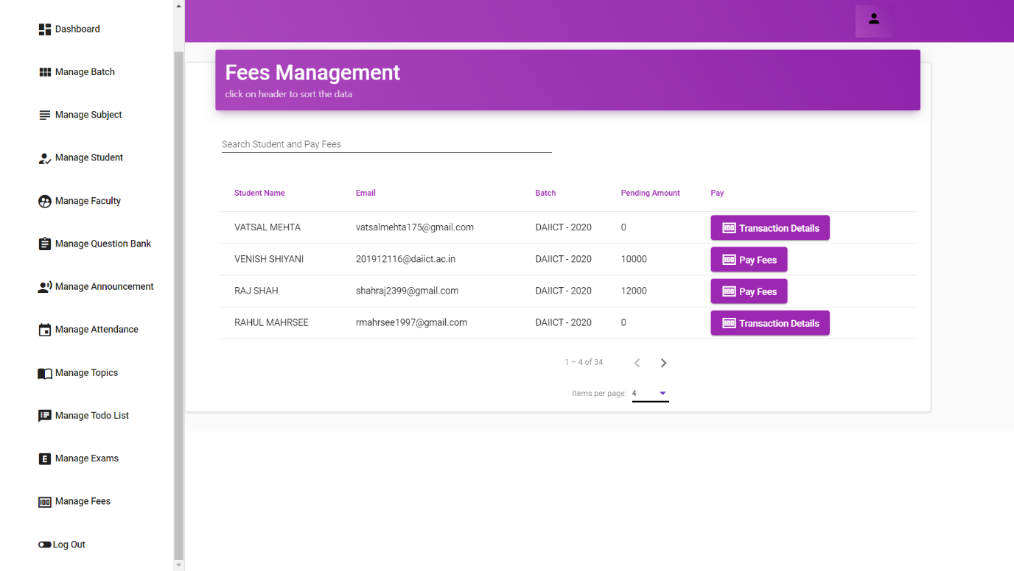

* + 1. Create a Fees Transaction

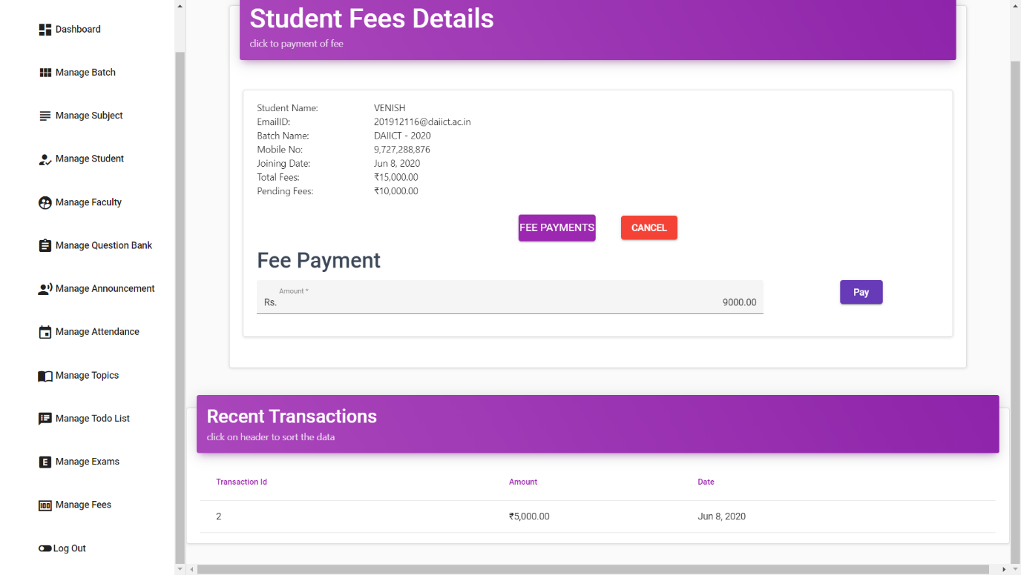

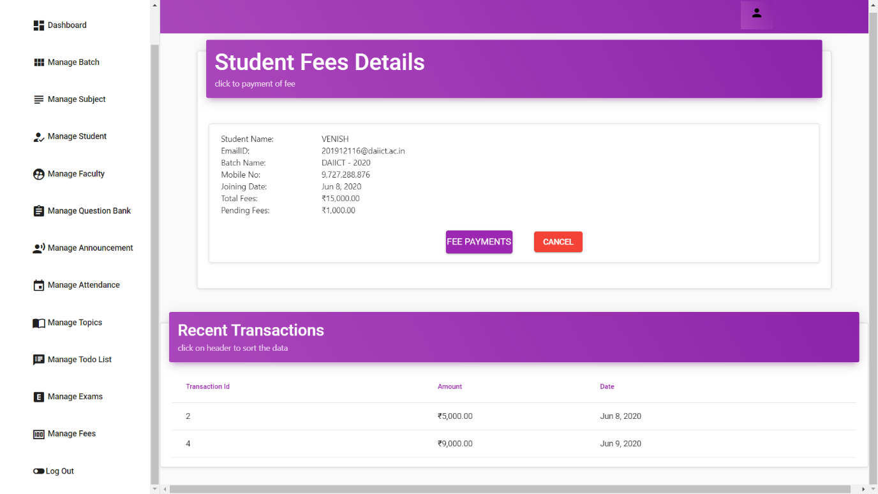

* 1. **Note**

1. **Faculty** who have access to dashboard, question bank, announcement, attendance, todo list and exams.
2. **Tutor** who have access to dashboard, question bank, announcement, attendance, todo list, exams and fees.

**For more description on faculty’s and tutor’s functionality with snapshots you can refer to our user manual.**

1. **Snapshots of Student Side**

**8.1 Dashboard**

* Once the student Login into the application, the screen will look as below:

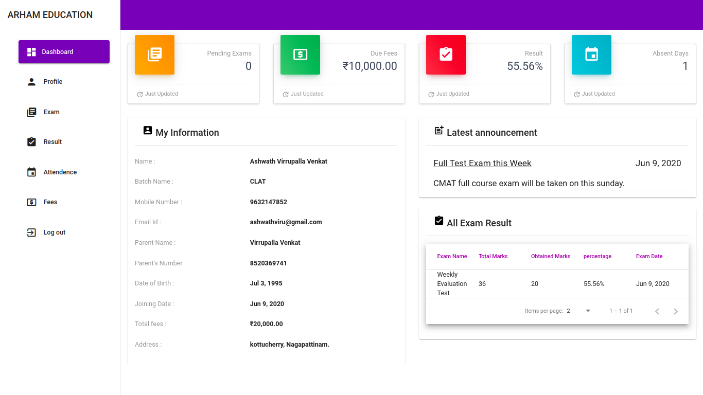

5

4

3

6

7

2

1

1. Pending Exam :-

show total number of pending exams.

2. Due Fees :-

show total Due Fees Amount.

3. Result :-

Show Average of percentage base on Total given exam by student.

4. Absent Days :-

show total number of absent day.

5. My information :-

show all information about student.

6. Latest Announcement :-

show all announcement which created by admin, tutor and faculty.

7. Recent exam Result :-

show recent exam result

**8.2 Profile**

* students can updatestheir mobile numbers and Address.

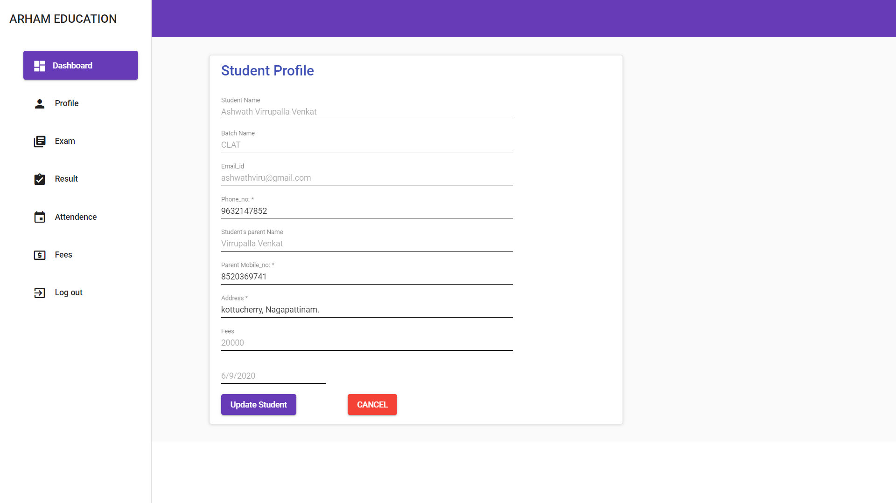

* change your mobile number.
* change your parent mobile number.
* change your Address.
* click update student button.

**8.3 Exam**

* show all pending exam*

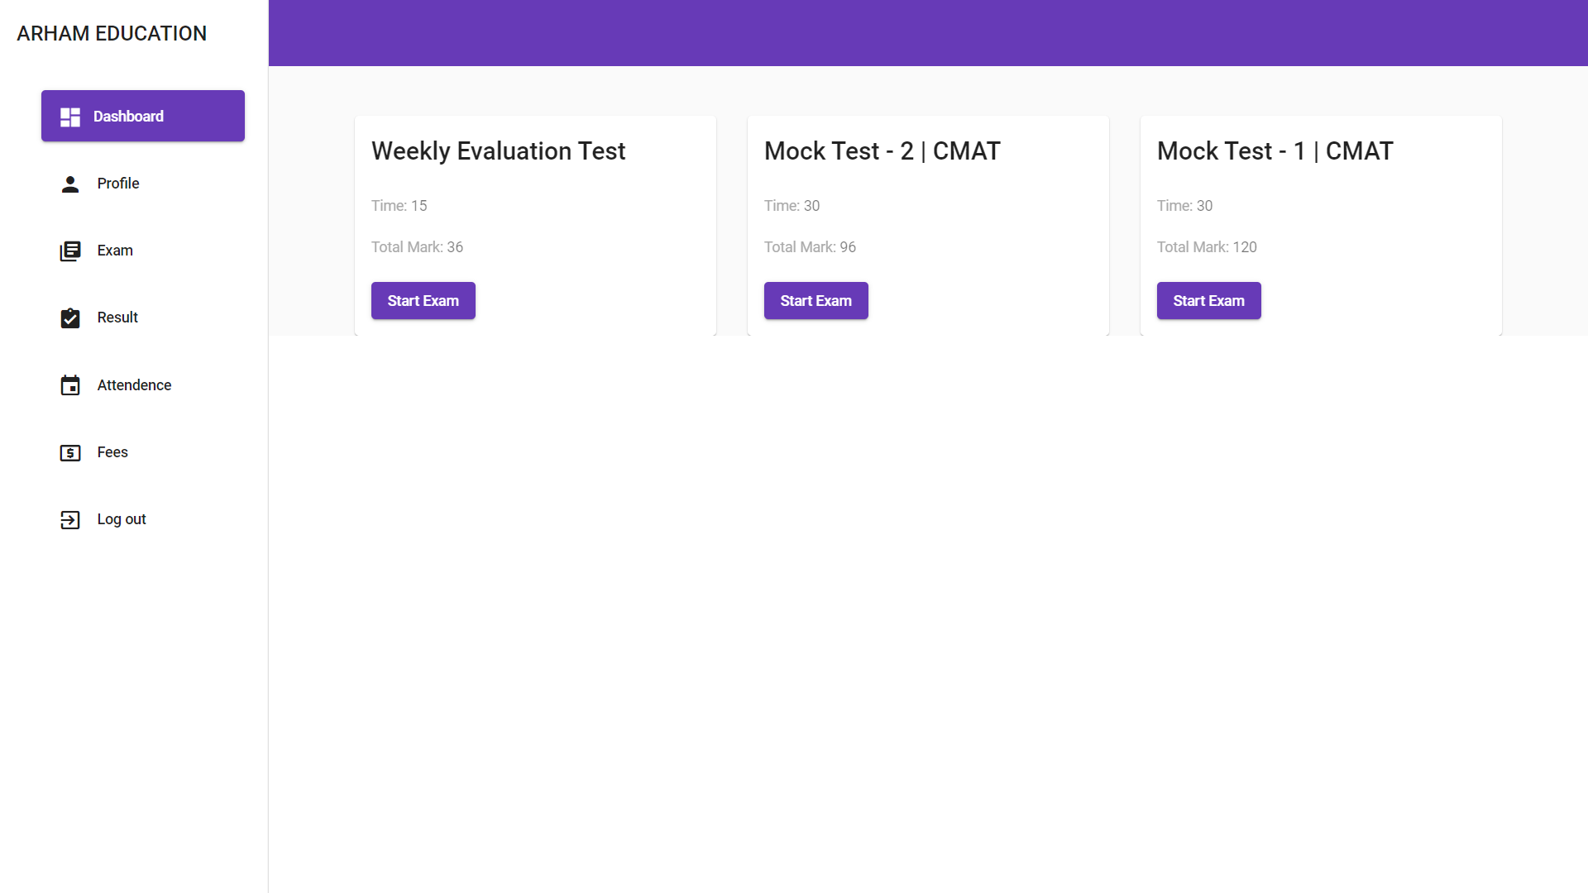

**8.3.1 Start Exam**

* when student click start exam then the screen looks like below :

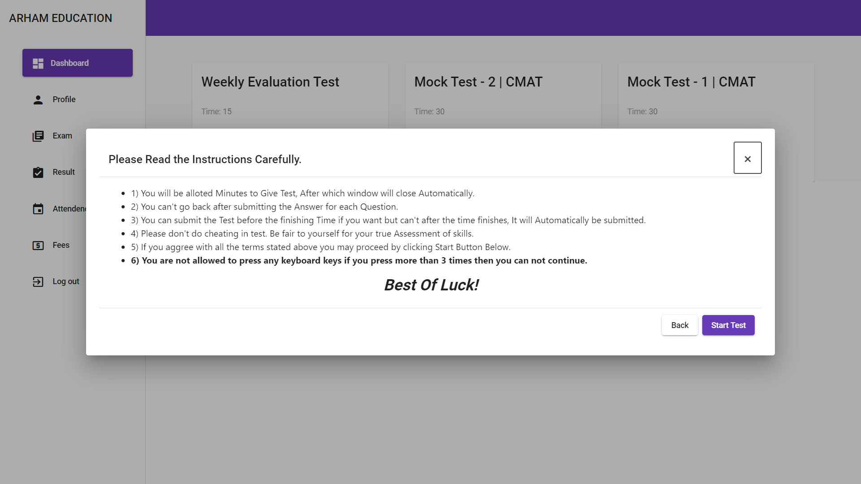

* When student click start test button then student show question of exam. Looks like below:

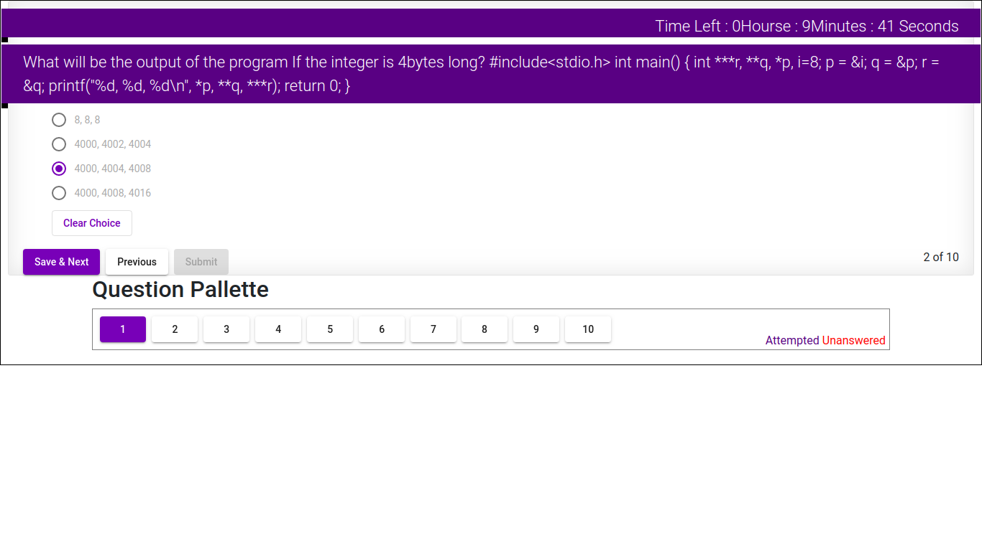

1. Remaining time :-

Right side top Conner student show remaining time of exam

2. Clear Choice :-

when student choose wrong answer by mistake that time student clear their answer choice.

3. Save and Next :-

student can save their answer and go to next question.

4. Previous :-

if student want to go to previous question that time this button use.

**8.3.2 Security of exam**

* when student presses any key of keyboard at that time warning box shows of exam ending.
* Student can press any key only three times while giving exam after that the exam will be stopped automatically.
* When student presses key during exam that looks like below:

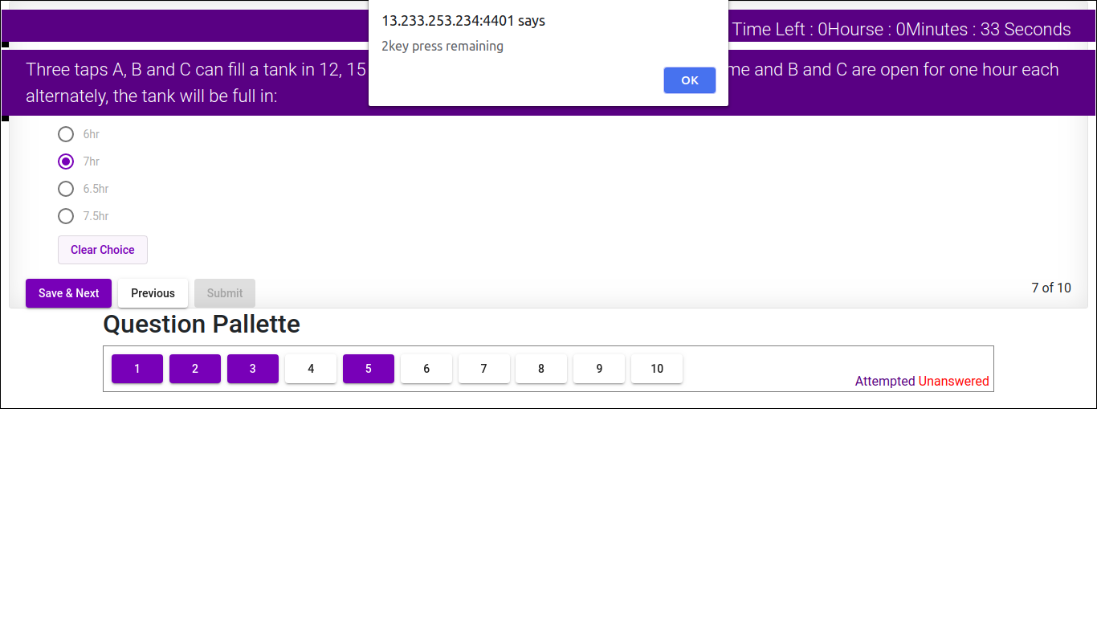

**8.3.3 End Exam**

* there are two scenarios of End of exam, first is when student click on submit button and other is time up.
* 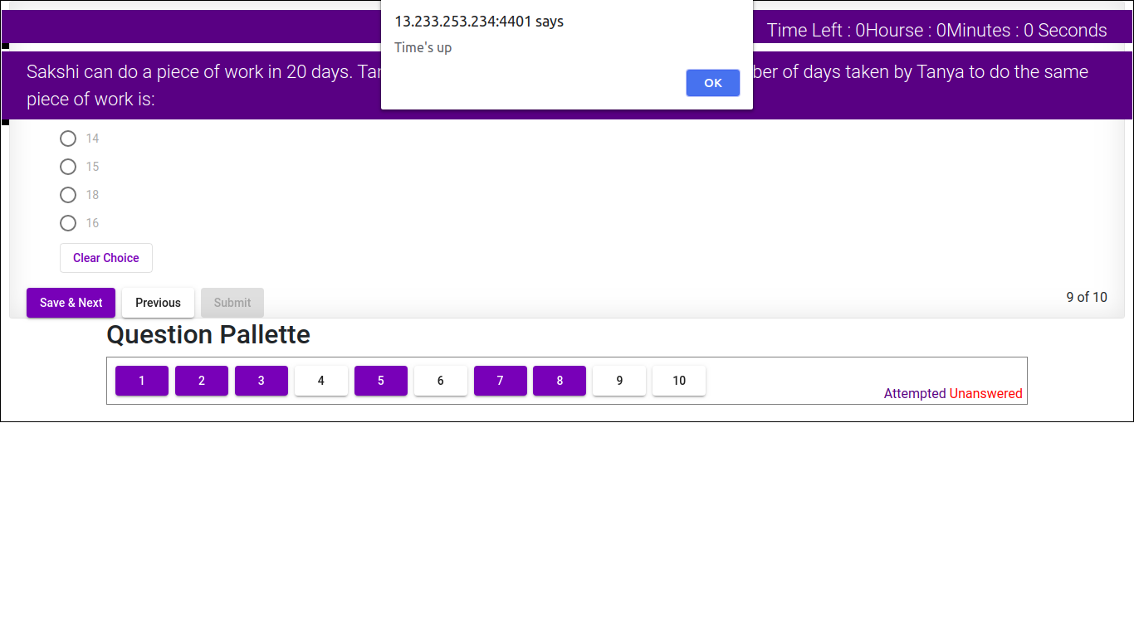When time up of exam that time student show time up alert box, looks like below and exam will be finished.
* 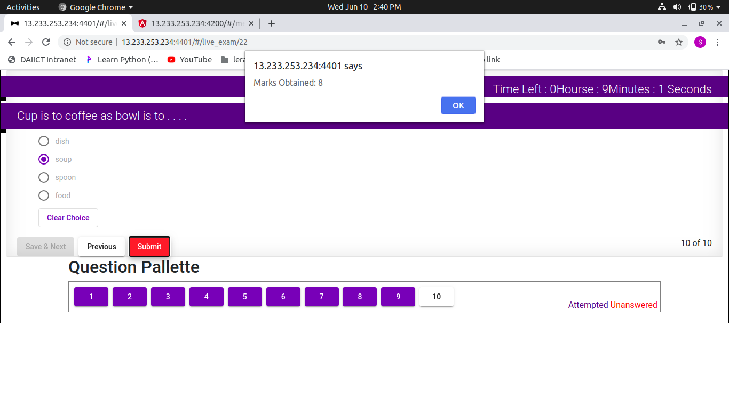When student click submit button then exam will be finish and show total obtain mark in alert box. Its look like below:

**8.4 Result**

* student can view of all exam result which is give already.

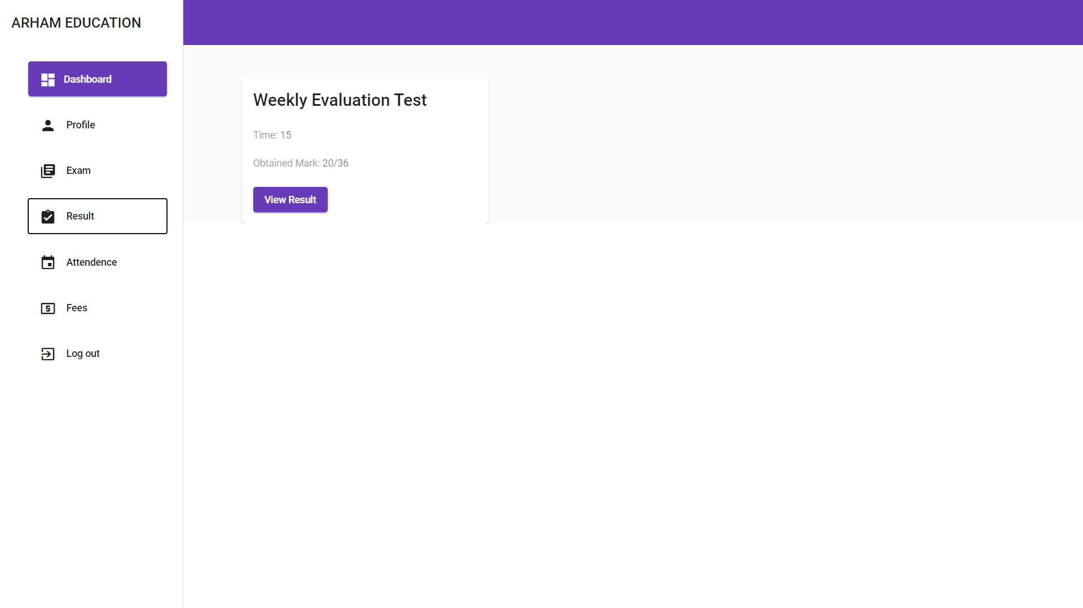

**8.4.1 View Result**

* when student click view result button that time screen looks like below:

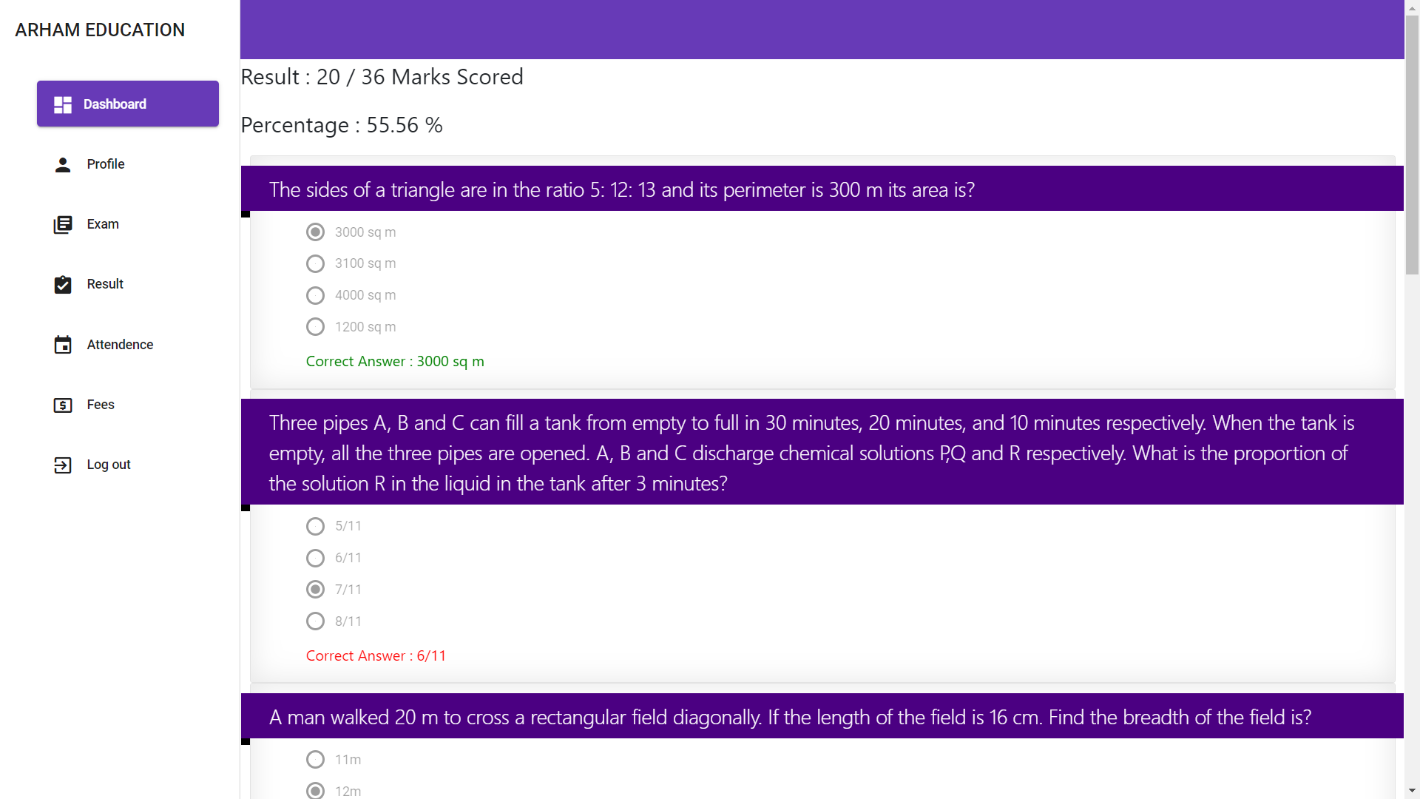

* student show all question with correct answer.
* Student show theirparticular exam of obtain mark and percentage.
* If student give wrong answer then correct answer show with red colour.
* If student give right answer then correct answer show with green colour.

**8.5 Attendance**

* student show theirattendance. Its looks like below:

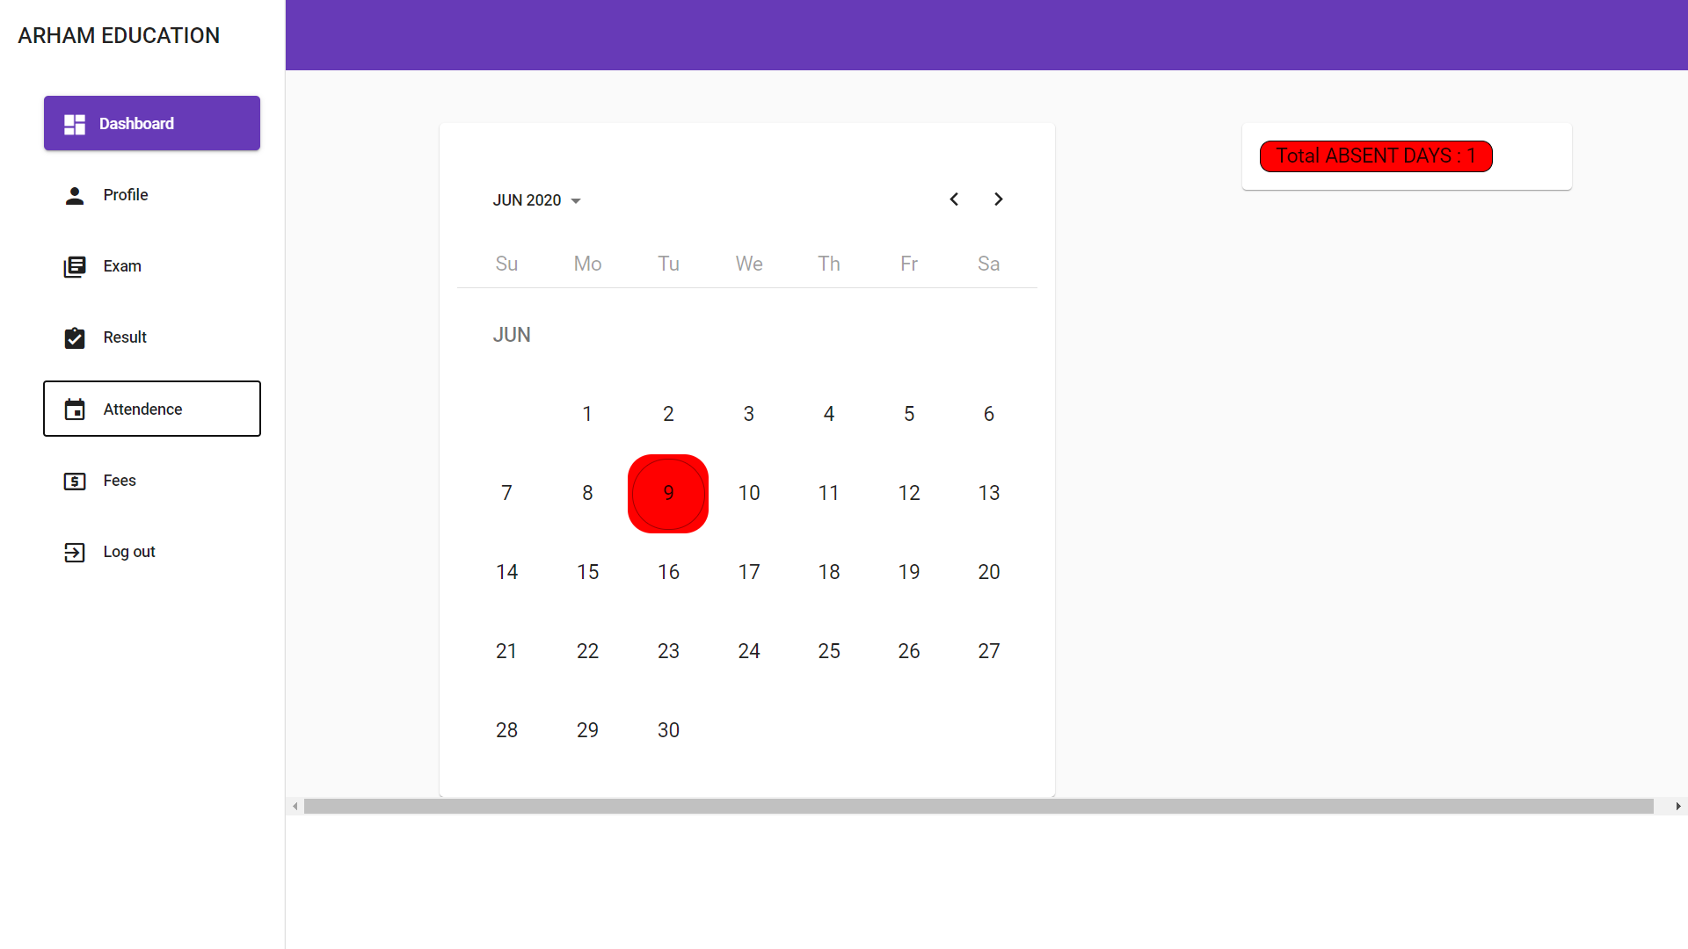

* student show their total number of absent days in top right corner.
* Its also show their previous months attendance using calendarcontroller option.

**8.6 Fees**

* Student show their fees transaction. Its looks like below:

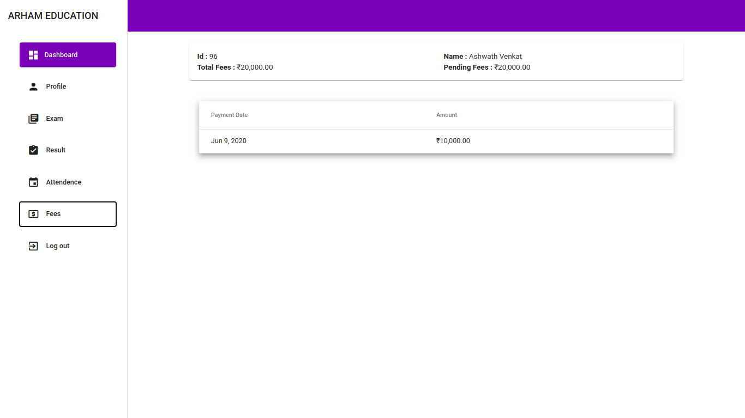

**9. Testing**

**9.1 Testing Plan**

This document is a test plan for Arham Institute Management System with it describes the testing strategy and approach to testing. The team will use this to verify that application meets the established requirements specified by the clients.

* 1. **Test Strategy**

**9.2.1 Unit testing:**

Test the smallest piece of verifiable software in the application.

**9.2.2 Automatic testing:**

Checks the system faster and repeatedly.

**9.2.3 Integration testing:**

Individual software modules are combined and tested as a group.

**9.2.4 System testing:**

Connected on a complete, integrated system to evaluate the system’s compliance with its specified requirement

**9.2.5 User Acceptance testing(Beta Testing):**

UAT(Beta Testing) is carried out in the production environment or the client’s environment. The users here are the actual customers.

* 1. **Pass/Fail criteria for testing**

|  |  |  |  |
| --- | --- | --- | --- |
| **Module Name** | **Applicable Roles** | **Input** | **Pass/Fail Criteria** |
| Login | Admin  Tutor  Faculty  Student | Enter Credentials | If credentials valid then user logged in  Else  Enter Valid Credentials |
| Forgot Password | Admin  Tutor  Faculty  Student | Enter Email-id | If valid then OTP sent for reset password  Else  Enter valid Email-id |
| Change Password | Owner  Operator | Enter Old Password  Enter New Password  Enter Confirm Password | If old password is valid then check whether new and confirm password matches then change password successful  Else  Enter Valid Details |
| Profile | Owner  Operator | Can Update  Mobile number  Or  Address | If entered data is valid for all the field then item will be updated successfully |
| Online exam | Student |  | If any pending exam is there Student can give exam |
| View Result | Student |  | If student has given any Exams, he can view that exam result in detail. |
| View attendance | Student |  | Student can view his Attendance month wise |
| View fees | Student |  | Can see the unpaid fees amount  And can also see the details of the paid fees. |
| Dashboard | Student |  | Its shows total pending exams, Due fees, overall result, no. of absent days,  View personal-details, exam marks, view Announcements |
| Dashboard | Admin |  | It will show total numbers of students, total number of batches,  Total employee of the institute, Total no of question added, Some chart representation, and recent fees transaction. |
| Batch | Admin | Enter Batch name | If valid batch name is entered it will be added and  Admin can also view the existing batches and search it. |
| Subject | Admin | Enter Subject name | If subject name is entered it will be added and  Admin can also view the existing subject and search it. |
| Student manage | Admin | Enter first name, last name, middle name, parent name, address, email-id, password, mobile number, DOB, batch, gender, fees | If entered data is valid then student will be added  Else enter valid student details  Can also update Student Information  And delete it. |
| Faculty management | Admin | Enter type of faculty, Email-id, password, Name, phone number, Qualification, DOB, salary | If entered data is valid then faculty will be added  Else enter valid faculty details  Can also update faculty Information  And delete it |
| Questions | Admin | Enter Question, Four options, Right answer, Enter Subject, Enter topic, and its difficulty level. | If entered data is valid then Question will be added  Else enter valid Question details  Can Also view existing question  Can also update Question  And delete it |
| Announcement | Admin | Enter Title, Announcement details, Date, batch | If entered data is valid then Announcement will be added  Can Also view Announcement  Can also update Announcement  And delete it |
| Attendance | Admin | Select batch  And then deselect absent student | Attendance will be recorded |
| Topic | Admin | Select Subject  And enter topic name | If entered data is valid then topic will be added  Can Also view topic  Can also update topic |
| To-Do List | Admin | Enter to do list details | To-Do list will be added  Can Also view To-do list  Can also update To-do list  And delete it |
| Online –Exam | Admin | Enter Exam name, select batch, select subject, time for exam, and select the question generation type  -Random  Just add number of questions  -custom  Selects topic,  Select number of questions as per difficulty | Exam Will be created  Can also view the created exam |
| Fees | Admin | Enter amount | If entered data is valid then Fees will be deducted from total fees |

* 1. **Test Report**

**9.4.1 Unit Test:**

* + **Objective :** 
    - Unit testing, a testing technique using which individual modules are tested to determine if there are any issues by the developer himself. It is concerned with functional correctness of the standalone modules.
  + **Techniques :**
    - Black Box Testing - Using which the user interface, input and output are tested.
    - White Box Testing - used to test each one of those functions behaviour is tested.
  + **Report Summary:**

|  |  |  |  |
| --- | --- | --- | --- |
|  | **Total Cases** | **Pass Cases** | **Fail Cases** |
| **Unit_Test_1.0** | **85** | **53** | **32** |
| **Unit_Test_2.0** | **85** | **85** | **0** |

**9.4.2 Integration Test:**

* + **Objective :**
    - Upon completion of unit testing, the units or modules are to be integrated which gives raise to integration testing. The purpose of integration testing is to verify the functional, performance, and reliability between the modules that are integrated.
  + **Techniques :**
    - Big Bang Approach - Here all component are integrated together at once and then tested. It is convenient for small systems.
  + **Report Summary :**

|  |  |  |  |
| --- | --- | --- | --- |
|  | **Total Input data** | **Pass Input data** | **Fail Input data** |
| **Integration Testing Report 1.0 admin** | **56** | **54** | **2** |
| **Integration Testing Report 2.0 admin** | **2** | **2** | **0** |
| **Integration Testing Report 1.0 student** | **15** | **11** | **4** |
| **Integration Testing Report 2.0 student** | **4** | **4** | **0** |

**9.4.3 System Test:**

* + **Objective :** 
    - System Testing (ST) is a black box testing technique performed to evaluate the complete system the system's compliance against specified requirements. In System testing, the functionalities of the system are tested from an end-to-end perspective.
  + **Techniques :**
    - System test falls under the black box testing category of software testing.
    - White box testing is the testing of the internal workings or code of a software application. In contrast, black box or System Testing is the opposite. System test involves the external workings of the software from the user's perspective.
  + **Report Summary :**

|  |  |  |  |
| --- | --- | --- | --- |
|  | **Total Cases** | **Pass Cases** | **Fail Cases** |
| **Student_System_Test** | **18** | **18** | **0** |
| **Admin_System_Test** | **30** | **30** | **0** |

**9.4.4 Acceptance Testing:**

* + **Objective :**
    - Acceptance testing, a testing technique performed to determine whether or not the software system has met the requirement specifications. The main purpose of this test is to evaluate the system's compliance with the business requirements and verify if it is has met the required criteria for delivery to end users.
  + **Report Summary :**

|  |  |  |
| --- | --- | --- |
| **Total Cases** | **Pass Cases** | **Fail Cases** |
| **21** | **21** | **0** |

**9.5.5 Automatic Testing:**

* + **Objective :** 
    - Check the system faster and repeatedly.
  + **Techniques :**
    - Used selenium for automated testing.
  + **Report Summary :**
    - Please refer Automatic testing generated file for that.

**10. Conclusion**

**10.1 Assumptions and dependencies**

* The users have sufficient knowledge of computers
* The institution computers should have Internet connection and Internet server capabilities
* The users know the English language, as the user interface will be provided in English
* The product can access the institution’s student database

**10.2 Limitations**

* Students can press escape, alt+tab key to navigate while giving exam (though students are warned by the system if they press any key to navigate)

**10.3 Future scope**

* Solution of each question can be provided which can help students in clearing their doubts after the exam is given
* The faculty can be provided with functionality of selecting each and every question manually
* The institution can be provided with an online payment gateway for salary and fees payment